TORFAEN COUNTY BOROUGH COUNCIL

SCHOOL COMPLAINTS PROCEDURE

1. INTRODUCTION

  - Section 29 of the Education Act 2002 requires the governing bodies of all maintained schools in Wales to establish procedures for dealing with complaints from parents, pupils, members of staff, governors, members of the community and others. This includes complaints about the school and any community facilities or services. The law also requires governing bodies to publish their complaints procedure.The provisions of section 29 came into force on 1 September 2003

  - There are separate and established procedures already in existence for some complaints. This procedure should NOT be used for complaints relating to:

- Curriculum
- Special Educational Needs (SEN)
- Religious Worship
- Admissions
- Exclusions
- Staff Grievance
- Teacher Capability
- Staff Disciplinary
- Child Protection Issues (see 5.8b)

  - This complaints procedure is a way of ensuring that anyone with an interest in the school (parents, members of staff, governors, pupils, members of the local community and others) can raise a concern, with confidence that it will be heard and if well founded, addressed in an appropriate and timely fashion.

  - It provides a clear and straightforward procedure where school staff and governors are clear about their roles and responsibilities in responding to complaints.

  - By incorporating the essential element of record keeping, the progress of the complaint can be easily tracked. This can also assist the school in defending its actions if the complainant has recourse to an external body and enables schools to learn from issues raised and improve.

  - The procedure acknowledges that by treating all complaints seriously and responding to them quickly often means that they can be resolved at the earliest stage.

  - It is a statutory requirement that a summary of the procedure must be published in the school prospectus. The full document must be made available to all parents, pupils, governors, the LEA, diocesan authority and all those who request a copy. All staff must be given a copy to make them aware of their role in relation to the procedure. A copy must be given to all new parents, staff and governors.

2. SETTING UP A GOVERNING BODY COMPLAINTS COMMITTEE AND COMPLAINTS APPEALS COMMITTEE

2.1 Complaints Committee

The governing body will set up a Complaints Committee every year at its Annual General Meeting. It could use the same members who sit on the staff grievance or staff disciplinary committee. Usually the committee will consist of three governors with the membership renewed annually. The Headteacher should not be a member of the complaints committee or appeals committee.

The governing body may appoint a person who is not a member of the governing body to a Complaints Committee providing the majority ofmembers are governors. The governing body may wish to give consideration to co-opt an LEA officer (complaints officer for example) onto the committee to assist them in consdering complaints. The governing body may also determine whether non-governor members have voting rights, but no vote can be taken at a committee meeting unless the majority of members present re members of the governing body.

- General Complaints about the School (see Diagram 1 and the notes below)
THREE STAGES

3.1 Stage One - Complaint raised with (and resolved by) the first recipient within the School

The complaint may be made orally or in writing. It can be made to:

- A member of staff
- Head of year
- Headteacher
- Designated Complaints Officer (if provided)

Where possible, the first recipient and the Complainant should make every effort to resolve complaints at this stage.

The Complainant should be given the opportunity to meet the member of staff with whom they have raised the matter usually within 10 school days. This is to ensure that a decision is reached and conveyed to the complainant.

If the complaint can’t be resolved to the satisfaction of the Complainant, the member of staff should inform the Complainant, orally or in writing, that they are entitled to take the complaint to the Headteacher. The Complainant should be provided with a copy of the school’s complaints procedure if they have not already been given a copy.

If the Headteacher is the first recipient of a complaint, he or she can decide whether to delegate consideration to another member of staff under Stage One or to proceed to Stage Two

3.1.1 Stage One - Record Keeping

- Name and address of the Complainant
- Date of receipt of the complaint
- Brief Description of the complaint
- Action taken to resolve the complaint and outcome
- Issues for action by the school and lead member of staff

CHECK! - At all stages of the complaints process it should be made certain that the substance of the complaint is not one that should be dealt with under any other procedure e.g. staff capability, staff grievance, staff discipline or child protection. If the issues raised require action under other procedures then those should take precedence and should be implemented.

3.2 Stage Two – Consideration by the Headteacher

The complaint will not normally move to Stage Two until it has first been considered under Stage One. The matter might proceed immediately to Stage Two if the Headteacher thinks it is appropriate.

At this stage the Complainant should be encouraged to put the complaint in writing so that its substance is clear. If this is not possible, then the school may consider making arrangements for the complainant to convey their complaint by another method e.g. by arranging for it to be dictated and signed.

On receipt, the Headteacher will acknowledge the complaint in writing, enclosing a copy of the complaints procedure and giving a target date for providing a response. This would usually be within 10 school days. If this is not possible, the Complainant will be informed when consideration of the matter is to be concluded.

The Complainant will be given the opportunity to meet with the Headteacher. Interpretation facilities or assistance for disabled persons should be made available. The Complainant may wish to be accompanied by a relative or friend. The Headteacher may wish to have another person present to witness the discussion.

The Headteacher should convey his or her decision in writing to the complainant.

3.2.1 Stage Two – Record Keeping

- Name and Address of the Complainant
- Date and Details of the complaint
- Action taken to resolve the complaint and a written record of discussions, interviews, telephone conversations and evidence collated
- Outcome
- Date of notification to complainant
- Issues for action by the school and lead member of staff

3.3 Stage Three – Consideration by the Governing Body

If a Complainant is not satisfied with the outcome of the consideration by the Headteacher, the governing body may then consider the matter.

At this stage school who are signed up to the Governor Support Service will be entitled to support in arranging and clerking meeting of the complaints committee.

The governing body will wish to satisfy itself that Stage One and StageTwo have been exhausted before considering the matter or that there are special reasons for not following Stage One and StageTwo.

The Complaints Committee will then hear the complaint.

The membership of the committee will be checked before each hearing to ensure that no member of the committee has had perceived or actual involvement in the matter. Care will be taken that no committee member has any personal links with either the complainant or the person against whom the complaint has been made. If there is any doubt about a person’s ability to act impartially or fairly or there may be a conflict or potential conflict of interest, the governing body has final decision whether that person should be a member of the committee or any appeal committee. Substitute members may be appointed as necessary.

The Chair of Governors will ask the Clerk to the Governing Body (Governor Services) to acknowledge receipt of the complaint usually within 5 working days and then to arrange for the Governing Body Complaints Committee to meet to hear the complaint usually within 15 school days of the date of receipt of the complaint. The Clerk (Governor Services) will check to make sure that all parties are available to attend.

The letter of acknowledgement will:

- make clear to all parties that they are entitled to provide evidence / written documentation that they wish the committee to consider;
- give the date that such written evidence should be provided;
- give the date that documents will be forwarded to the person complained about;
- give the date that the person complained about must return their response (usually within 10 school days to allow them time to consider all the evidence and take advice);
- the date that the response will be made available to the complainant; and
- the date of the hearing (if available at this point)

The Chair of the Committee will ensure that all parties are given at least 5 school days notice of the date of the meeting in writing.

The letter arranging the Complaints Committee hearing should;

- give the time and place of the hearing;
- give the grounds for the complaint, with copies of all relevant documents;
- inform all parties of their right to be accompanied by a person of their choice;
- give details of those attending and their respective roles;
- state that the committee may proceed with an oral hearing in the absence of either or both parties, if no good reason is given why they should not do so; and
- state the entitlement of the parties to request an adjournment if there is a good reason why they cannot attend.

  - Stage Three – Complaints Hearing Procedure

3.4.1 Purpose: To enable members of the governing body Complaints Committee to clarify facts and ascertain whether there are grounds for upholding the complaint.

    - The Chairman of the Committee should introduce all persons present. He/ she should explain that the committee is impartial and that committee members may ask questions of any person during the hearing.

3.4.3 The Clerk to the Governing Body (Clerk or Governor Services) will be present to make a record of the meeting.

3.4.3 The Complainant (or their Representative) is invited by the Chair to explain their complaint.

3.4.4 The Complainant may call his/her witness/es to give their evidence.

3.4.5 The Complainant sums up his/her complaint.

3.4.6 The Headteacher or other appropriate witness should then explain the schools action.

3.4.7 Any witnesses for the school may be called to give evidence.

3.4.8 The Headteacher should sum up the schools actions and its response to the complaint.

3.4.9 The Chair of the Committee informs both parties that they will hear from the committee in writing, usually within 5 school days.

3.4.10 Both parties and all witnesses leave whilst the Committee discusses and makes a decision on the matter. The Clerk will remain with the committee.

3.4.11 The Complaints Committee should consider its decision in private. Before doing so, it can take advice from advisers i.e. Representatives of the LEA, Diocesan Authority or other relevant body. Such advisers should leave once their advice has been given

Stage Three – The Decision

The Committee should base its decision upon the following:

- the evidence;
- whether the Headteacher or others have complied with the school’s complaints procedure; and
- whether there is substance to the complaint.

The decision should be made by majority agreement with a second or casting vote from the Chair as necessary. The decision letter needs to include:

  - Whether or not the complaint is upheld;
  - Any action to be taken by the governing body, Headteacher and/or members of staff in light of the decision;
  - Any recommendations for changes to school policies or procedures to ensure similar problems do not arise in future.;
  - A full account of the proceedings of the complaints committee and any appeal committee, evidence presented and all other relevant documentation; and
  - The decision reached and any action to be taken by the school, Headteacher, governing body or member of staff
  - Details of the right to appeal and to whom (Clerk or Governor Services)
  - The date by which an appeal needs to be lodged, usually 15 school days after the day on which notice in writing was given of the committee’s decision
  - That any appeal must set out the grounds on which it is made

The decision will be sent to all parties usually within 5 school days of the hearing. At this stage all parties should have an understanding of the reasons for the decision and be satisfied that, even if they have not been successful, the hearing has been fair.

Stage Three – Record Keeping

- A full account of the proceedings of the Complaints Committee and any appeal committee, evidence presented and all other relevant documentation
- Decision reached and any action to be taken by the school, Headteacher, governing body or member of school
- Date of the decision and date the decision letter was sent to the complainant

- CLOSING THE COMPLAINT

If, at the end of Stage Three, the complaint is not upheld, the decision letter should make clear:

- that the complaint has been thoroughly investigated;
- the governing body and the Headteacher will not re-open the matter;
- any new issues will not mean re-opening an already determined complaint; and
- if new issues arise these will be treated as a new complaint but only if demonstrably different from matters raised under a previous complaint.

5. IF THE COMPLAINT CONCERNS….

  - IF THE COMPLAINT CONCERNS….The Headteacher – (see Diagram 2 and the notes below)

If the complaint is about the Headteacher, the person first receiving it should refer it to the Chair of Governors. He/she should:

The Chair of Governors may choose to investigate the complaint him/herself or delegate investigation of the complaint to the vice Chair or other designated governor. He or she may wish to delegate the investigation, for example, if he / she has had prior involvement in the matter. Whichever governor carries out the investigation will not then be a member of the Complaints Committee. The investigating governor should declare any potential conflicts of interest.

The complaint should be in writing. If this is difficult for the Complainant, the school should consider making arrangements for the Complainant to convey their complaint by another method e.g. by arranging for it to be dictated and signed.

The Chairman, or investigating governor, will acknowledge receipt of the complaint in writing and usually within 10 school days, enclosing a copy of the complaints procedure and giving a target date for a response to be given. If it is not possible to deal with the matter within this time, the complainant will be told and given a date when to expect the matter to be concluded.

The Complainant will be given the opportunity to meet with the Chairman or investigating governor. Interpretation facilities or assistance for disabled persons should be made available, if necessary. The Complainant may wish to be accompanied by a relative or friend. The Chairman or investigating governor may wish to have another person present to witness the discussion.

The Chairman or investigating governor should convey his or her decision in writing to the Complainant.

Record Keeping - Complaint against a Headteacher

- Name and address of the Complainant
- Date and details of the complaint
- Action taken to resolve the complaint and a written record of discussions, interviews and evidence collated
- Outcome
- Date of notification to Complainant
- Issues for action by the school and lead member of staff

If the Complainant is not happy with the outcome then he/ she will be advised to write to :

- The Vice Chair – if the Chair carried out the investigation, or
- The Chair – if the Vice Chair or another delegated governor carried out the investigation

who will refer the matter to the Chair of the Complaints Committee for consideration in accordance with Stage Three.

  - IF THE COMPLAINT CONCERNS….The Complaints Officer (see Diagram 3 and the notes below)
If the Headteacher has assigned a member of staff as a Complaints Officer to deal with complaints at Stage One and the complaint concerns the Complaints Officer, the complaint will be passed to the Headteacher.

The Headteacher can decide to delegate the investigation to another senior member of staff to investigate under Stage One or to investigate it him/ herself under Stage Two.

If the Complainant is not happy with the outcome he/she should be advised to write formally to the chair of governors in accordance with Stage Three.

  - IF THE COMPLAINT CONCERNS….The Chair of Governors (see Diagram 4 and the notes below)

Any Complaints against the Chair of governors should be sent to the Vice Chair who should immediately inform the Headteacher, the LEA (and, where appropriate, the Diocesan authority). The Vice Chair should:

- check whether or not the matter should be dealt with under this complaints procedure or whether the matter needs to be referred to another authority such as the police or social services
- should also consider whether to obtain advice from the LEA (or Diocesan authority if appropriate).

The Vice Chair of Governors may choose to investigate the complaint him/herself or delegate investigation to another designated governor. Alternatively, the Vice Chair may refer the matter directly to the Complaints Committee. The Chair of the complaints committee will then proceed to Stage Three.

It is recommended that the matter is not brought to the governing body’s attention until it has been determined by the complaints committee and any appeal committee.

The complaint should be in writing. If this is difficult for the Complainant, the school should consider making arrangements for the Complainant to convey their complaint by another method e.g. by arranging for it to be dictated and signed.

The Chairman, or investigating governor will acknowledge receipt of the complaint in writing and usually within 10 school days, enclosing a copy of the complaints procedure and giving a target date for a response to be given. If it is not possible to deal with the matter within this time, the Complainant will be told and given a date when to expect the matter to be concluded.

The Complainant will be given the opportunity to meet with the Chairman or investigating governor. Interpretation facilities or assistance for disabled persons should be made available, if necessary. The Complainant may wish to be accompanied by a relative or friend. The Chairman or investigating governor may wish to have another person present to witness the discussion.

The Chairman or investigating governor will convey his or her decision in writing to the Complainant.

  - IF THE COMPLAINT CONCERNS….The Chair and Vice Chair (see Diagram 5 and the notes below)

Any complaint about the Chair and Vice Chair should be referred to the Clerk to the Governing Body who will refer the matter to the chair of the complaints committee. The Chair will seek advice from the LEA (and, if appropriate, the Diocesan Authority) and arrange for the complaint to be heard by the Complaints Committee in accordance with Stage Three.

If the Chair of the Complaints Committee is the chair or vice chair of governors, the complaint should be referred t the chair of the complaints appeal committee who should become the chair of the complaints committee for this particular case. The Complaints appeal committee would then need a new chair. If the posts of chair of the complaints committee and chair of the complaints appeals committee are held by the chair and vice chair of the governing body, then both committees will need to appoint a new chair.

  - IF THE COMPLAINT CONCERNS….The Headteacher and the Chair of Governors (see Diagram 4 and the notes below)

Complaints against the Headteacher and Chair of Governors should be sent to the Vice Chair of Governors who will inform the LEA (and, if applicable, the Diocesan Authority). The Vice Chair should:

- check whether or not the matter should be dealt with under this complaints procedure or whether the matter needs to be referred to another authority such as the police or social services
- will also consider whether to obtain advice from the LEA or Diocesan authority.

The Vice Chair of Governors may choose to investigate the complaint him/herself or delegate investigation another designated governor. Alternatively, the vice chair may refer the matter directly to the Complaints Committee. The Chair of the Complaints Committee should then proceed to Stage Three.

  - IF THE COMPLAINT CONCERNS….A Governor (including the Vice Chair) or a Group of Governors (see Diagram 6 and the notes below)

If your complaint is against the actions of one governor or a group of governors, you should refer it to the Chair who will deal with it in the same way as if the complaint had been made against the Headteacher.

If the Chair is involved as part of the group being complained about, the complaint should be sent to the vice chair who will deal with it in the same way as if the complaint had been made against the Headteacher.

If the Chair and Vice Chair are both involved as part of the group being complained about, the complaint should be given to the Clerk to the governing body. The Clerk will forward the complaint to the Chair of the Complaints Committee for action under Stage Three.

If the Chair of the Complaints Committee is the Chair or Vice Chair, the Clerk should refer it to the Chair of the Complaints Appeals Committee who will then become the Chair of the Complaints committee for that case.

If the matter proceeds to Stage Three, care will be taken to make sure that the members of the complaints committee can be seen to be impartial.

If the number of governors who are subject of the complaint result in there being too few governors to form a Complaints Committee, then the procedure for complaints against a whole governing body (below) will be used.

5.7 IF THE COMPLAINT CONCERNS…. The Whole Governing Body

Any complaint against the actions of a whole governing body should be sent to the Clerk to the governing body who will immediately inform the Headteacher, Chair, the LEA and, as appropriate, the diocesan authority.

The LEA will then consider whether the matter is causing such concern that it can issue a warning notice to the governing body in accordance with its powers of intervention. (See Section 15 of the School Standards and Framework Act 1998 as amended by the Section 55 of the Education Act 2002).

If this is not necessary, then the LEA, ( and/or if appropriate the Diocesan Authority) will seek the agreement of the governing body to have the complaint heard by a specially constituted and independent committee.

If the LEA (and/or the Diocesan authority) decide not to take any action, they will ask the Clerk to inform the Complainant that the matter will be raised at the next meeting of the governing body. The Chair may arrange a Special meeting to consider the matter, if the next meeting is some time away.

The Complainant may be informed of the proposed action, date and time of the governing body meeting. He or she may be allowed the same opportunity to give written and verbal evidence as if the matter was being dealt with by the Complaints Committee.

The governing body may look at evidence and arrive at a decision in the same way that its complaints committee would. The clerk may then send the following information to the Complainant:

- The decision and an explanation of the reasons for the decision

- An explanation that if the Complainant remains dissatisfied, he or she can ask the LEA, (Diocese , if appropriate) or the Welsh Assembly Government to review the procedure used by the governing body to deal with the complaint but not the decision.

5.8 IF THE COMPLAINT CONCERNS….Alleged Criminal Activity

A) FINANCIAL

If the complaint appears to involve alleged criminal activity, the person who first receives the complaint should immediately refer the matter to the Headteacher.
If the Headteacher is the subject of the allegation, the complaint should be referred to the Chair of Governors who will, without delay, inform the relevant authorities i.e. Police, and/or District Audit, the LEA and if applicable the Diocesan Authority.

If the complaint involves both the Headteacher and the Chair , the complaint should be forwarded to the Vice Chair.

If the complaint of alleged criminal activity against the Headteacher and the Chair concerns financial issues, the complaint should be referred to the vice chair and/or the Chair of the Finance Committee (provided they are not the subject of the allegation), who should contact the LEA, the relevant authorities, and if applicable the diocese.

If the Headteacher, Chair, Vice Chair and Chair of the Finance Committee are all included in the allegation, and there is no other suitable governor available to accept the complaint, the Complainant will be advised to send their complaint to the clerk to the governing body who will refer the matter to the LEA (and if appropriate the Diocesan authority).

B) CHILD PROTECTION

If the complaint appears to involve a child protection issue, the person first receiving the complaint should refer it to the designated child protection teacher. The School will be able to give contact details. If the designated child protection teacher is the subject of the allegation, the matter should be referred to the Headteacher.

Often the Headteacher is the designated child protection teacher . If this is the case and the Headteacher is the subject of the allegation then the Complainant should immediately inform the LEA.
(See also www.learning.wales.gov.uk for current guidance.)

6. PRINCIPLES

The governing body is committed to the following principles for dealing with complaints in this procedure.

  - Impartiality and fairness

The Complaints procedure will be applied consistently and with fairness to all parties.

At stage one it is possible that the person dealing with the complaint may have had prior involvement or interest in the matter.

However, at Stage Two and Three, all persons dealing with the complaint will be impartial having had no prior involvement or interest.

  - Investigating complaints

At each stage, the person dealing with the complaint will

- Establish what has happened so far, and who has been involved
- Clarify the nature of the complaint and what remains unresolved
- Meet with the complainant or contact them if unsure or if further information is needed
- Clarify what the Complainant feels would put things right
- Talk to those involved, talk to those complained about (allowing them to have a friend present if they wish)
- Approach matters with an open mind
- Keep records

  - Handling Information

All complaints will be kept confidential, with only those involved in investigating and making a decision being made aware of the details of the complaint.

The person who is being complained about will also be entitled to know the substance of the complaint against them. The governing body has discretion to withhold information when there is sufficient reason, such as:

- Where there is a need to protect a source
- Where there is a legal reason why the information should not be released
- To meet data protection requirements

  - Complaints involving pupils

Pupils can become involved in the process by

- either making a complaint,
- being the subject of a complaint, or
- as a witness.

The governing body will carefully handle complaints involving pupils and at each stage the pupil concerned may be accompanied by his or her parent / guardian or an adult of the pupil’s choice.

Although pupils under the age of 16 may provide evidence, this would need to be done voluntarily and with their parents’ consent. The governing body will ensure that appropriate techniques are used to hear evidence from a child witness to ensure that the child’s view is properly heard.

(The governing body will refer to guidance that is shortly due to be issued, when available. This guidance will give details of the specific arrangements for dealing with complaints involving pupils, and will include the support that will need to be given to pupils and advocacy arrangements.)

  - Timing

The governing body will make every effort to investigate complaints quickly to avoid the stress that unnecessary delay causes and also in recognition of the fact that during a protracted process memories fade or positions become entrenched.

The governing body is committed to keeping all parties informed throughout the process and may issue a timetable of events for all parties to be aware of what will happen and when.

The governing body wishes to draw attention to the use of the word “usually” alongside the number of school days that would be reasonable for each stage. This is in recognition of the fact that the timeframe might be changed with the agreement of the parties; and that some cases may take longer due to their complexity or the absence of key parties due to ill health etc.

Where it becomes clear that investigation and decision is likely to take longer than the procedure would normally suggest, the governing body, if satisfied that the delay is justifiable, will notify the Complainant and the subject of the complaint in writing of the departure from the timetable and the reasons.

Where a complaint is made shortly before a school holiday (not half term or occasional days) the governing body will make every effort to resolve it before the school closes.

  - Anonymous Complaints

The governing body will deal with anonymous complaints as follows:

- If the complaint concerns alleged criminal conduct or is a child protection issue, it should be treated as explained at 5.8 above
- In other cases, the person receiving the complaint needs to make a judgement as to whether it should be investigated.
- Details of anonymous complaints may be recorded and included in any report or analysis concerning complaints

  - Withdrawal of complaints

If a complainant withdraws their complaint, the governing body will record that the complaint has been withdrawn and send a letter of acknowledgement to the Complainant.

  - Roles and Responsibilities

The Governing Body expects all parties to behave reasonably, treating the process and parties involved with respect. An example of this would be ensuring that everyone is made aware of meeting dates.

The governing body may allow adjournment of a meeting or hearing on request if the timing is inconvenient. However, last minute cancellation or attempts to thwart the process by repeatedly failing to agree dates may not be allowed.

The governing body will allow the Complainant, and the person(s) against whom the complaint is made, to be accompanied by a friend, advocate, union representative, colleague, parent or other person at each stage.

  - Recording Complaints

The governing body will keep an appropriate record of all complaints including anonymous and withdrawn complaints. A record will be kept for the following reasons:

- To monitor the progress of a complaint
- To provide evidence that the complaint was considered and of the outcome
- For reference, if further complaints arise relating to the original issue
- To identify trends or recurring themes in complaints cases
- To compile Complaints Reports

The record will also show where the complaints procedure has been reviewed by the LEA and/or Diocesan Authority, and /or the Welsh Assembly Government and will include any documentation relating to those reviews.

The governing body will keep records of complaints at each stage as detailed previously.

Anonymous or withdrawn complaints, or complaints regarded as of being vexatious, frivolous or malicious will be recorded as follows:

- Description of the complaint
- Whether the complaint was investigated or just recorded
- The outcome of any investigation
- Any issues for action by the school and the lead member of staff

Subject to compliance with the Data Protection Act, the records will be made available to the LEA, Diocesan Authority for inspection and also in the course of an inspection of the School.

Records of complaints will be kept for three school years including the year in which the complaint was finalised.

  - Reporting and Monitoring Complaints

Reports summarising key trends and issues on complaints should be made to the governing body at least twice a year. This report will be compiled by the Headteacher or other persons designated by the governing body.

The governing body will use the reports to consider the number and subject of complaints, to identify any trends or areas of concern and make recommendations for action.

The report (or a summary) will also be presented to the school council and to parents. A summary may also be included in the annual report to parents.

- WHO DOES WHAT?

  - The Headteacher and the Governing Body

The Headteacher and the Governing Body both have a role in hearing complaints, adjudicating and deciding on the action to be taken. However, the ultimate responsibility lies with the Governing Body who can overrule the action of the Headteacher.

No individual or organisation can overrule the decision of the governing body. The Courts may uphold a challenge to a governing body decision-making process. The Welsh Assembly Government may also issue a direction to the governing body if it has acted unreasonably or failed to comply with its duty.

The Governing Body decision could be overruled where there are other statutory processes for complaints not administered by the governing body e.g. Special Educational Needs, Curriculum, Exclusions, Admissions or Religious Worship.

  - Local Education Authority/ Diocesan Authority

LEAs and Diocesan Authorities do not have a statutory role in resolving complaints about schools – the statutory responsibility rests with the governing body.

However Schools and parents can seek advice and aassistance from LEA officers at a an early stage to mediate and prevent concerns progessing to a formal stage. Schools can also ask for an LEA officer to be co-opted on the complaints committee to assist them in investigating the complaint.

The procedures may allow for an additional stage for the LEA (or the Diocesan Authority, if appropriate) to review the procedure used to reach a decision, not to review the decision itself or to act as an appeal mechanism. If the LEA (or Diocesan Authority) concludes that the process followed in a particular case was deficient, it could ask the governing body to reconsider the matter with a committee of different membership from the original complaints and complaints appeal committee.

The LEA or Diocesan Authority should keep the school informed of the progress of any review and should, at the end of the process, provide copies of documentation, including the decision, to the school for the school’s records.

  - Welsh Assembly Government

If the Welsh Assembly Government is the first recipient of a complaint about a school that is not covered by another statutory complaints procedure, the Welsh Assembly Government will advise the Complainant to raise the matter with the school under the school complaints procedure.

If a complainant is dissatisfied about the procedures used by a governing body to address a complaint, he or she can ask the Welsh Assembly Government to consider its actions. The Minister may conclude that a governing body has acted unreasonably or has failed to carry out a statutory duty under education law (which would include failure to deal with a complaint). The Welsh Assembly Government can issue a direction to the governing body to reconsider the matter or consider it for the first time if it has failed to do so, or to amend its process to ensure it does not happen again.

(“unreasonable” has been defined by the Courts as action that no sensible authority acting with due appreciation of its responsibilities would have decided to adopt.

  - Children’s Commissioner

The Children’s Commissioner for Wales has a wide-ranging statutory remit covering all children in Wales. It embraces the actions of the Welsh Assembly Government, LEAs and Schools.

The Commissioner may:

- Provide advice, assistance, information and support to children in making a complaint or representation
- Review and monitor arrangements made for dealing with complaints, whistleblowing and advocacy, or the absence of such arrangements
- Investigate individual cases submitted to him

In reviewing complaints processes, the Commissioner’s role is to make sure that they are working effectively and enable children and young people to exercise their rights. The Commissioner may serve notice on the body or person to be reviewed and has a statutory power to require information from teachers, school governors, local authority officers and members. The Commissioner may produce reports, which contain recommendations. He has no statutory power to require their implementation but he can publicise any failure to do so.

In individual cases, The Commissioner has a statutory right to require information, explanations and assistance in relation to action taken in response to a complaint. The Commissioner does not take the place of existing complaints procedures nor act as an avenue of appeal.

  - Commissioner for Local Administration in Wales (also known as Local Government Ombudsman)

Most of the responsibilities of school governing bodies fall outside the remit of the Commissioner for Local Administration in Wales (CLAW). The only exception being schools admissions appeals. However this may change. The CLAW is one of three Ombudsman offices in Wales that are to be unified into a Public Services Ombudsman for Wales.

  - General Teaching Council for Wales (GTCW)

The GTCW is the statutory, self-regulating professional body for teachers in Wales. It seeks to raise he status of teaching by maintaining and promoting the highest standards of professional practice and conduct in the interests of teachers, pupils and the general public.

The GTCW has a responsibility for investigating and hearing cases of unacceptable professional conduct or serious professional incompetence concerning a registered teacher or cases where a registered teacher has been convicted (at any time of a relevant offence).

School Governing Bodies and LEAs are required to report cases to the Assembly or the GTCW where they “cease to use” or “might have ceased to use” a registered teachers services had he or she not resigned. The GTCW’s Disciplinary Procedures and Rules set out the procedures for dealing with any cases received.

The GTCW may also consider referrals about a registered teacher from a person other than a governing body or LEA, for example a pupil, parent or fellow teacher. In such circumstances, the GTCW will ask whether the complainant has reported the allegation to the school governing body or LEA and, if so, what the outcome was. If the complainant has not reported the allegations to the school governing body or the LEA, the GTCW will ask for the reasons why this has not been done. The GTCW will not normally investigate an allegation that has not been referred to a school governing body.

  - Complaints Made to Other Parties Outside the School

Complainants may make their fist approach to the police, another statutory body, the LEA. a local or national elected representative or a voluntary organisation. The governing body may provide such organisations with their complaints procedure encouraging them to contact the school if the complainant contacts them.

If such parties receive complaints about a school they will wish to take account of the statutory responsibility of the governing body for the resolution of complaints.

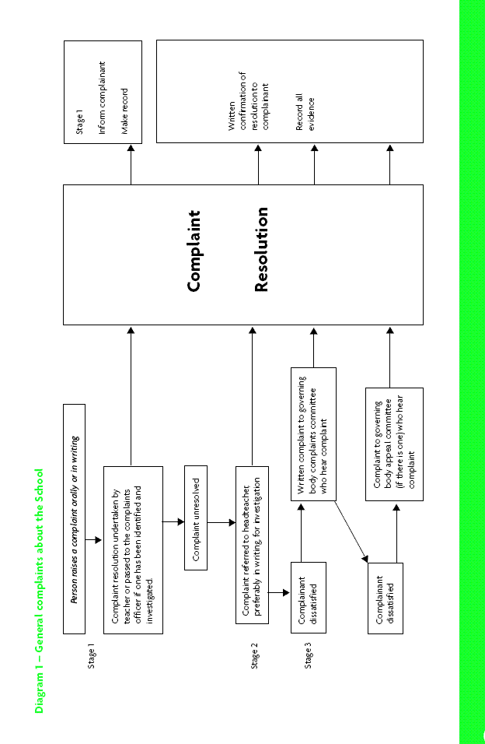

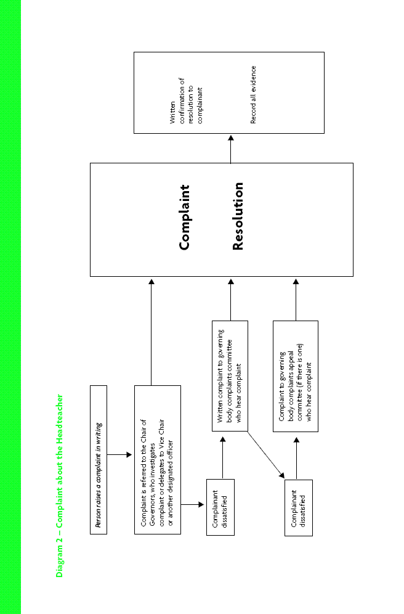

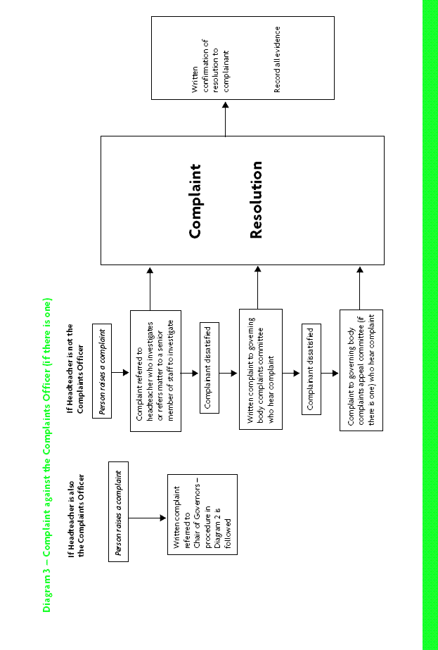

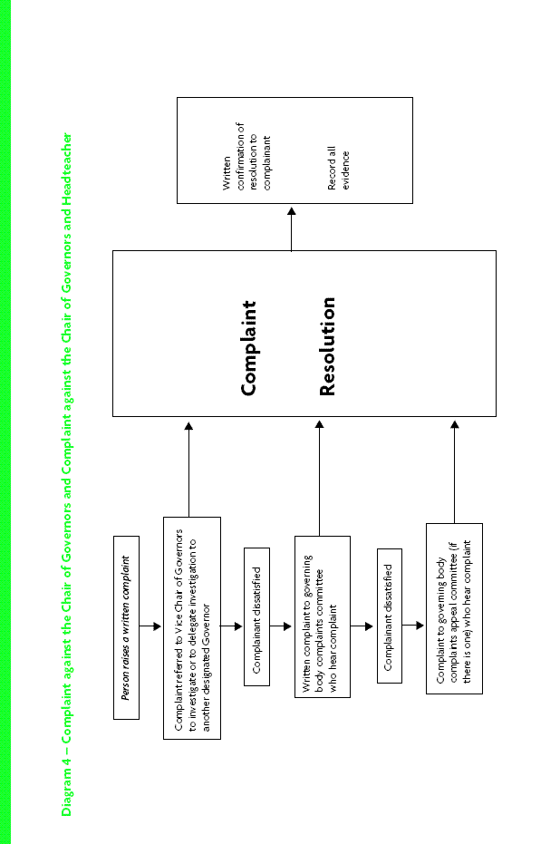

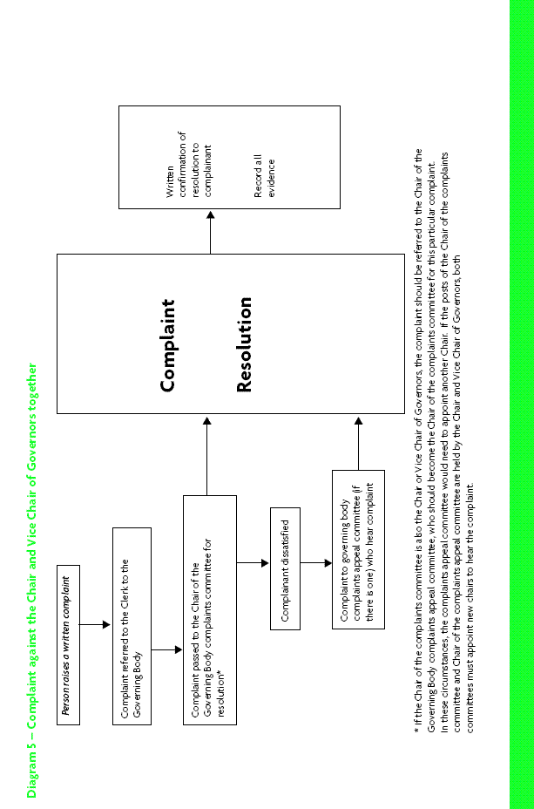

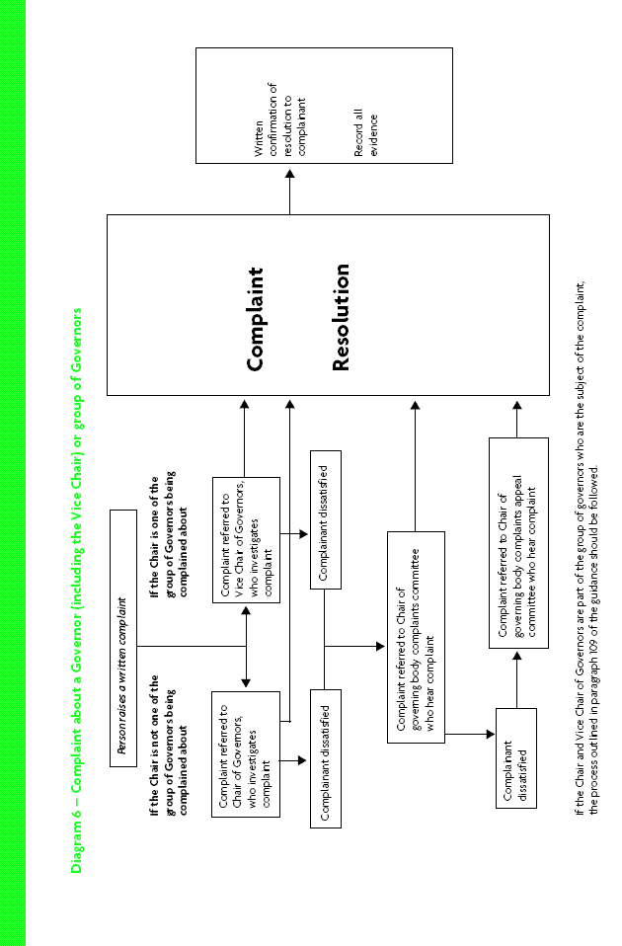

CONFIDENTIAL
COMPLAINT FORM

- Read the Complaints policy and follow the steps and stages.
- You can use this form to let the School know of your complaint.
- Give this form to a member of staff, Head of Year, other member of staff or the Headteacher.

Your Name

Your Address

Your Postcode

Your Telephone Number(s)

Your e- mail address

Today’s Date

Data Collection Statement
The School may use information gathered from this form to record your complaint. We will only use your information for this purpose and will not give it to anyone else without your permission.

Please write full details of your complaint here including all relevant facts, dates, times and people involved

Please continue on a separate piece of paper if you need more space

The School wishes to make sure that everyone is given equal access to its complaints procedure. You can help the school by answering the following questions:

Are you: Male Female

Do you have a disability? Yes No

What is your age group?

Under 19 20-29 30-39 40-49

50-59 60-69 over 70

What is your ethnic origin? (Please circle one)

WHITE  British  English  Scottish  Welsh  Irish  Other  Please write in | MIXED  White & Black  Caribbean  White & Black African  White & Asian  Other  Please write in | ASIAN  Asian British  Asian English  Asian Scottish  Asian Welsh  Indian  Pakistani  Bangladeshi  Other Please write in | BLACK  Black British  Black English  Black Scottish  Black Welsh  Caribbean  African  Other  Please write in | CHINESE  Chinese British  ChineseEnglish  ChineseScottish  Chinese Welsh  Other  Please write in

