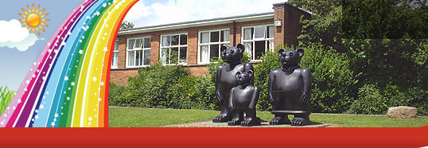
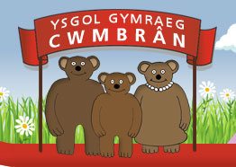

Ffordd Henllys,
Cwmbrân,
Torfaen
NP44 4HB
Ffôn: 01633 483383
Ffacs: 01633 485178
www.ysgolgymraegcwmbran.co.uk

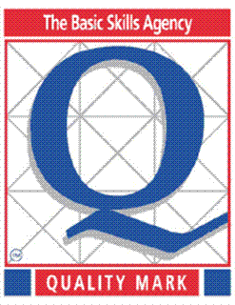
Ysgol Gymraeg Cwmbrân

Cywaith Ail-gylchu yr ysgol / The school’s Recycling Project
Annwyl Rieni/Warchodwyr,
Rydyn ni, fel ysgol, eisiau codi ymwybyddiaeth y disgyblion am ail-gylchu. Rydym wedi creu murlun yn y neuadd ac ein bwriad ni yw i lenwi’r murlun gyda thopiau poteli gwahanol liwiau. Y lliwiau rydyn ni eu hangen yw: coch, oren, melyn, gwyn, glas, gwyrdd tywyll a gwyrdd golau. Rydym yn gobeithio gorffen y murlun erbyn dydd Gwener y 9fed o Fehefin. Os oes topiau poteli gyda chi adref, danfonoch nhw mewn i’r ysgol dros yr wythnosau nesaf a bydd yr eco-bwyllgor yn eu casglu. Does dim ots os yw patrymau arnyn nhyw – byddwn yn eu gludo i lawr.

Dear Parents/Guardians,
We, as a school, want to raise the pupils’ awareness of recycling. We have created a collage in the school hall and our aim is to fill the collage with plastic bottle tops, in different colours. The colours we need are: red, orange, yellow, white, blue, dark green and light green. We hope that we will finish the collage by Friday the 9th of June. If you have any bottle tops at home, please send them in with your child over the next few weeks and our eco-commitee will collect them in. It doesn’t matter if they have patterns on the top of the lid as we’ll be gluing them down.

Diolch am eich cymorth / Thank you for your support, The School Council and the Eco-commitee.

Ffordd Henllys,
Cwmbrân,
Torfaen
NP44 4HB
Ffôn: 01633 483383
Ffacs: 01633 485178
www.ysgolgymraegcwmbran.co.uk

Ysgol Gymraeg Cwmbrân

Cywaith Ail-gylchu yr ysgol / The school’s Recycling Project
Annwyl Rieni/Warchodwyr,
Rydyn ni, fel ysgol, eisiau codi ymwybyddiaeth y disgyblion am ail-gylchu. Rydym wedi creu murlun yn y neuadd ac ein bwriad ni yw i lenwi’r murlun gyda thopiau poteli gwahanol liwiau. Y lliwiau rydyn ni eu hangen yw: coch, oren, melyn, gwyn, glas, gwyrdd tywyll a gwyrdd golau. Rydym yn gobeithio gorffen y murlun erbyn dydd Gwener y 9fed o Fehefin. Os oes topiau poteli gyda chi adref, danfonoch nhw mewn i’r ysgol dros yr wythnosau nesaf a bydd yr eco-bwyllgor yn eu casglu. Does dim ots os yw patrymau arnyn nhyw – byddwn yn eu gludo i lawr.

Dear Parents/Guardians,
We, as a school, want to raise the pupils’ awareness of recycling. We have created a collage in the school hall and our aim is to fill the collage with plastic bottle tops, in different colours. The colours we need are: red, orange, yellow, white, blue, dark green and light green. We hope that we will finish the collage by Friday the 9th of June. If you have any bottle tops at home, please send them in with your child over the next few weeks and our eco-commitee will collect them in. It doesn’t matter if they have patterns on the top of the lid as we’ll be gluing them down.

Diolch am eich cymorth / Thank you for your support, The School Council and the Eco-commitee.

