CASHLESS CATERING – QUICK GUIDE

Making Your First Payment
- Log in to your Torfaen account.
- On the top bar select ‘Products & Services’
- Select your child’s school under the ‘All Shops’ drop down bar.
- When you have selected the correct school locate what item you want to top-up. (Pupil School Meals or Tuck Money)
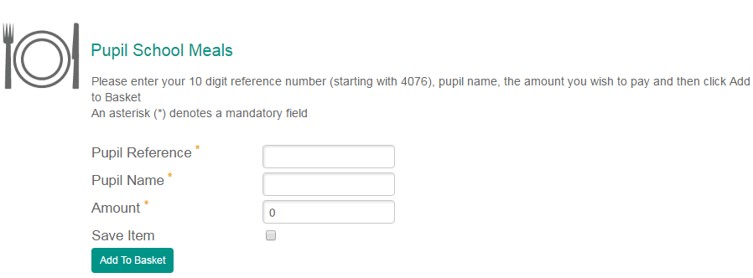

TO VIEW BALANCE & TRANSACTIONS

- Enter your child’s pupil reference number.
- Enter his/her name.
- Enter the amount you wish to pay. (This can be any amount)
- Click the box stating ‘Save Item’ as this will allow you to view the balances and transactions of school meals and tuck in the future for your child one working day from verification.
- Double check the information is correct!
- Click ‘Add To Basket’.

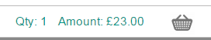
Checking Out
- Select your basket in the top right corner.
- Select ‘Checkout now’.
- Select your desired payment option.
- PayPal
- Credit Card
- Debit Card
- Continue with payment.
- When the payment is complete you’ll be provided with a receipt on-screen.

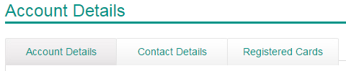
Saving Card Details (Optional)
- Select ‘My Account’ on the top bar.
- Select the ‘Registered Cards’ tab
- Click ‘Add new card’
- Fill in your card details and press ‘Next’. This will save your card details for faster payments in the future.

Viewing Balances and Transactions
FACILITY AVAILABLE ONE WORKING DAY AFTER VERIFICATION AND ACTIVITY HAS BEEN PRESENT ON YOUR CHILDS ACCOUNT, IF YOU TRY TO VIEW IT SOONER IT WILL STATE INVALID PIN IN ERROR.
- Log in to your Torfaen Account and select ‘Home’ on the top bar.
- Locate the item you have previously saved.
- Click ‘Verify Account’.
- Enter your child’s PIN and click ‘Next’
- Click ‘Home’ on the top bar again.
- It should state on the item ‘Item is verified’.
- The Pupil Reference number will turn into a green link once there has been activity on the account (A payment has been made or your child has used the account in school), this means from the next transaction your child makes it will start logging the balance and transaction history. Click the link to view the balance and transaction history.

Payments via the Automated Payments Line
You can also make payments via the Automated Payment Line Telephone Number
0300 456 0516.
You will be asked for the, The 4 digit School Code, The Pupil Reference Number and the Code for either Tuck or Dinner.

FOR A DETAILED GUIDE INCLUDING ANSWERS TO FREQUENTLY ASKED QUESTIONS, GO TO:
http://www.torfaen.gov.uk/en/EducationLearning/SchoolsColleges/Schoolcatering/School-Meals.aspx
AND DOWNLOAD FROM DOCUMENTS “Cashless Catering – A step by step guide to making an online payment”
IF YOU HAVE ANY QUESTIONS OR QUERIES, PLEASE CONTACT THE
CATERING TEAM
ON 01633 647726 / 647715 / 647719
EMAIL: cashless.catering@torfaen.gov.uk
WRITE TO: Cashless Catering, Croesyceiliog CEC, The Highway, Cwmbran NP44 2HF

