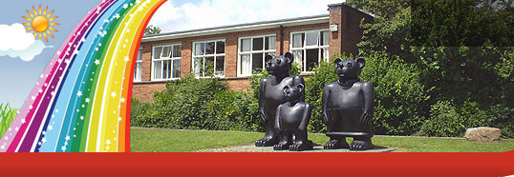
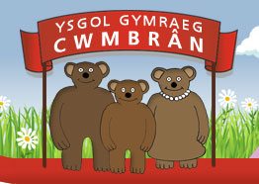

Ysgol Gymraeg Cwmbrân

Ffordd Henllys,
Cwmbrân,
Torfaen
NP44 4HB
Ffôn: 01633 483383
Ffacs: 01633 485178
www.ysgolgymraegcwmbran.co.uk

Perfformiad y Côr/ Choir Performance:
Annwyl Riant / Warchodwr,
Bydd disgyblion y côr yn mynd i ganu mewn cartref i’r henoed ddydd Mawrth. Rydych eisoes wedi rhoi caniatâd i’ch plentyn deithio ar fws felly ni fydd angen gwneud hwn eto. Os nad ydych chi am i’ch plentyn ganu ddydd Mawrth, cysylltwch gyda ni yn yr ysgol.
Bydd y disgyblion yn yr ysgol i fwyta eu cinio a bydd angen iddynt wisgo gwisg y côr os gwelwch yn dda.

Dear Parent / Guardian,
The choir will be singing Christmas carols at a home for the elderly on Tuesday. You have already given consent for your child to travel on a bus so this won’t need to be done again. If you don’t want your child to take part on Tuesday, contact us in the school.
The pupils will be in school to have lunch as usual and they will need to wear their choir uniform please.

Diolch / Thank you, Miss Griffiths and Miss Hughes.

Ysgol Gymraeg Cwmbrân

Ffordd Henllys,
Cwmbrân,
Torfaen
NP44 4HB
Ffôn: 01633 483383
Ffacs: 01633 485178
www.ysgolgymraegcwmbran.co.uk

Perfformiad y Côr/ Choir Performance:
Annwyl Riant / Warchodwr,
Bydd disgyblion y côr yn mynd i ganu mewn cartref i’r henoed ddydd Mawrth. Rydych eisoes wedi rhoi caniatâd i’ch plentyn deithio ar fws felly ni fydd angen gwneud hwn eto. Os nad ydych chi am i’ch plentyn ganu ddydd Mawrth, cysylltwch gyda ni yn yr ysgol.
Bydd y disgyblion yn yr ysgol i fwyta eu cinio a bydd angen iddynt wisgo gwisg y côr os gwelwch yn dda.

Dear Parent / Guardian,
The choir will be singing Christmas carols at a home for the elderly on Tuesday. You have already given consent for your child to travel on a bus so this won’t need to be done again. If you don’t want your child to take part on Tuesday, contact us in the school.
The pupils will be in school to have lunch as usual and they will need to wear their choir uniform please.

Diolch / Thank you, Miss Griffiths and Miss Hughes.

