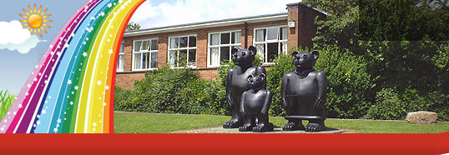
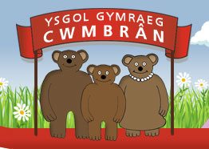

Ysgol Gymraeg Cwmbrân

Ffordd Henllys,
Cwmbrân,
Torfaen
NP44 4HB
Ffôn: 01633 483383
Ffacs: 01633 485178
www.ysgolgymraegcwmbran.co.uk

1af o Ragfyr 2016

Annwyl Riant/Warcheidwad

Cinio Nadolig / Christmas Lunch

Dydd Mercher / Wednesday - 14/12/16
Cyfnod Sylfaen/Foundation Phase - £2.10
Cyfnod Allweddol 2 / Key Stage 2 - £2.20

____________________________________________

Parti Nadolig / Christmas Party

Cynhelir Parti Nadolig i’r plant ar Ddydd Iau y 15fed o Ragfyr
Bydd ‘bwyd parti’ yn lle y dewis arferol o ginio poeth neu stondin salad a’r gost fydd £2 y disgybl. Gofynnwn yn garedig i chi ddanfon yr arian i mewn i’r ysgol erbyn y 13eg o Ragfyr.
Os nad yw eich plentyn yn dymuno cael y ‘bwyd parti’ bydd croeso i’ch plentyn i ddod â phecyn brechdanau i’r ysgol. Ni fydd Torfaen Catering yn darparu cinio ysgol arferol ar y diwrnod hwn. Caniateir i’r plant ddod i’r ysgol mewn dillad parti.

The children’s Christmas Party will be held on Thursday the 15th of December.
The usual hot dinner choice and salad bar will be substituted for ‘party food’ at a cost of £2 per pupil. Please send this into school by Tuesday the 13th of December.

If your child does not want/like ‘party food’ they are welcome to bring their usual packed lunch to school. Torfaen Catering will not be offering the usual school lunch on this day. The children will be allowed to come to school in party clothes.

Diolch yn fawr am eich cydweithrediad
Thank you for your co-operation

Catrin Evans
Pennaeth

