Ffordd Henllys,
Cwmbrân,
Torfaen
NP44 4HB
Ffôn: 01633 483383
Ffacs: 01633 485178
www.ysgolgymraegcwmbran.co.uk

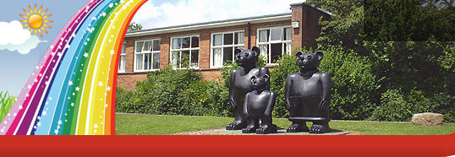
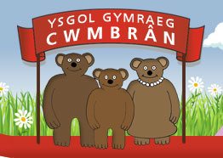

Ysgol Gymraeg Cwmbrân

Gweithdy E-Ddiogelwch i rieni / gwarchodwyr:
E-Safety workshop for parents / guardians:

Dear Parent/Guardian,
In Ysgol Gymraeg Cwmbrân, we feel that E-Safety is very important and pupils need to be aware of how to be safe online. PC Thomas will be holding a workshop to talk to year 6 pupils and there will be an opportunity for you as parents/guardians to learn about E-Safety on Thursday, 13th of October at 3:30 in Mr. Bridson’s class. Please come along to learn about E-Safety as we feel that parents and guardians need to be aware of how to keep children safe on line.

Annwyl Riant/Warchodwyr,
Yn Ysgol Gymraeg Cwmbrân, rydyn ni’n teimlo bod E-Diolgelwch yn bwysig iawn a bod angen i ddisgyblion fod yn ymwybodol o sut i fod yn ddiogel arlein. Bydd PC Thomas yn cynnal gweithdy E-Ddiolgelwch gyda rhieni / gwarchodwr ar nos Iau, y 13fed o Hydref, am 3:30 yn nosbarth Mr. Bridson. Dewch i’r cyfarfod er mwyn dysgu am sut i gadw’r disgyblion yn saff ar y we.
Thank you / Diolch, Ysgol Gymraeg Cwmbrân’s Digital Leaders.

Ffordd Henllys,
Cwmbrân,
Torfaen
NP44 4HB
Ffôn: 01633 483383
Ffacs: 01633 485178
www.ysgolgymraegcwmbran.co.uk

Ysgol Gymraeg Cwmbrân

Gweithdy E-Ddiogelwch i rieni / gwarchodwyr:
E-Safety workshop for parents / guardians:

Dear Parent/Guardian,
In Ysgol Gymraeg Cwmbrân, we feel that E-Safety is very important and pupils need to be aware of how to be safe online. PC Thomas will be holding a workshop to talk to year 6 pupils and there will be an opportunity for you as parents/guardians to learn about E-Safety on Thursday, 13th of October at 3:30 in Mr. Bridson’s class. Please come along to learn about E-Safety as we feel that parents and guardians need to be aware of how to keep children safe on line.

Annwyl Riant/Warchodwyr,
Yn Ysgol Gymraeg Cwmbrân, rydyn ni’n teimlo bod E-Diolgelwch yn bwysig iawn a bod angen i ddisgyblion fod yn ymwybodol o sut i fod yn ddiogel arlein. Bydd PC Thomas yn cynnal gweithdy E-Ddiolgelwch gyda rhieni / gwarchodwr ar nos Iau, y 13fed o Hydref, am 3:30 yn nosbarth Mr. Bridson. Dewch i’r cyfarfod er mwyn dysgu am sut i gadw’r disgyblion yn saff ar y we.
Thank you / Diolch, Ysgol Gymraeg Cwmbrân’s Digital Leaders.

