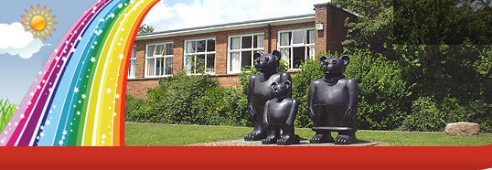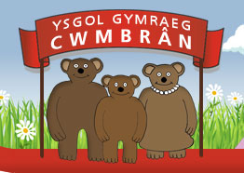

FforddHenllys,
Cwmbrân,
Torfaen
NP44 4HB
Ffôn: 01633 483383
Ffacs: 01633 485178
www.ysgolgymraegcwmbran.co.uk

Taith Llangrannog Blynyddoedd 5 a 6: Nodyn Atgoffa:
Diolch yn fawr iawn am dalu'r blaendal o £30 ar gyfer Llangrannog. Bydd angen i'r arian gael ei dalu'n llawn (£146) erbyn dydd Llun, Hydref 3ydd. Gallwch ddanfon arian mewn unrhyw bryd rhwng nawr a'r dyddiad hwnnw a byddaf i a Ms Painter yn cadw cofnod ysgrifenedig o bob taliad. Byddwn yn danfon mwy o wybodaeth i chi am y daith cyn hir.

Year 5 and 6 Llangrannog trip: Reminder note:
Thank you very much for paying the £30 deposit for Llangrannog. The money will need to be paid in full (£146) by Monday, October 3rd. You can pay the money in any time between now and this date and Ms Painter and I will keep a written record of every payment. We will send more information about the trip as soon as we receive it.

(*Some have paid in full already – this is just a reminder note.*)
If you have any more questions, please contact me in the school.
Diolch yn fawr / Thank you, Miss Passmore

FforddHenllys,
Cwmbrân,
Torfaen
NP44 4HB
Ffôn: 01633 483383
Ffacs: 01633 485178
www.ysgolgymraegcwmbran.co.uk

Taith Llangrannog Blynyddoedd 5 a 6: Nodyn Atgoffa:
Diolch yn fawr iawn am dalu'r blaendal o £30 ar gyfer Llangrannog. Bydd angen i'r arian gael ei dalu'n llawn (£146) erbyn dydd Llun, Hydref 3ydd. Gallwch ddanfon arian mewn unrhyw bryd rhwng nawr a'r dyddiad hwnnw a byddaf i a Ms Painter yn cadw cofnod ysgrifenedig o bob taliad. Byddwn yn danfon mwy o wybodaeth i chi am y daith cyn hir.

Year 5 and 6 Llangrannog trip: Reminder note:
Thank you very much for paying the £30 deposit for Llangrannog. The money will need to be paid in full (£146) by Monday, October 3rd. You can pay the money in any time between now and this date and Ms Painter and I will keep a written record of every payment. We will send more information about the trip as soon as we receive it.

(*Some have paid in full already – this is just a reminder note.*)
If you have any more questions, please contact me in the school.
Diolch yn fawr / Thank you, Miss Passmore

