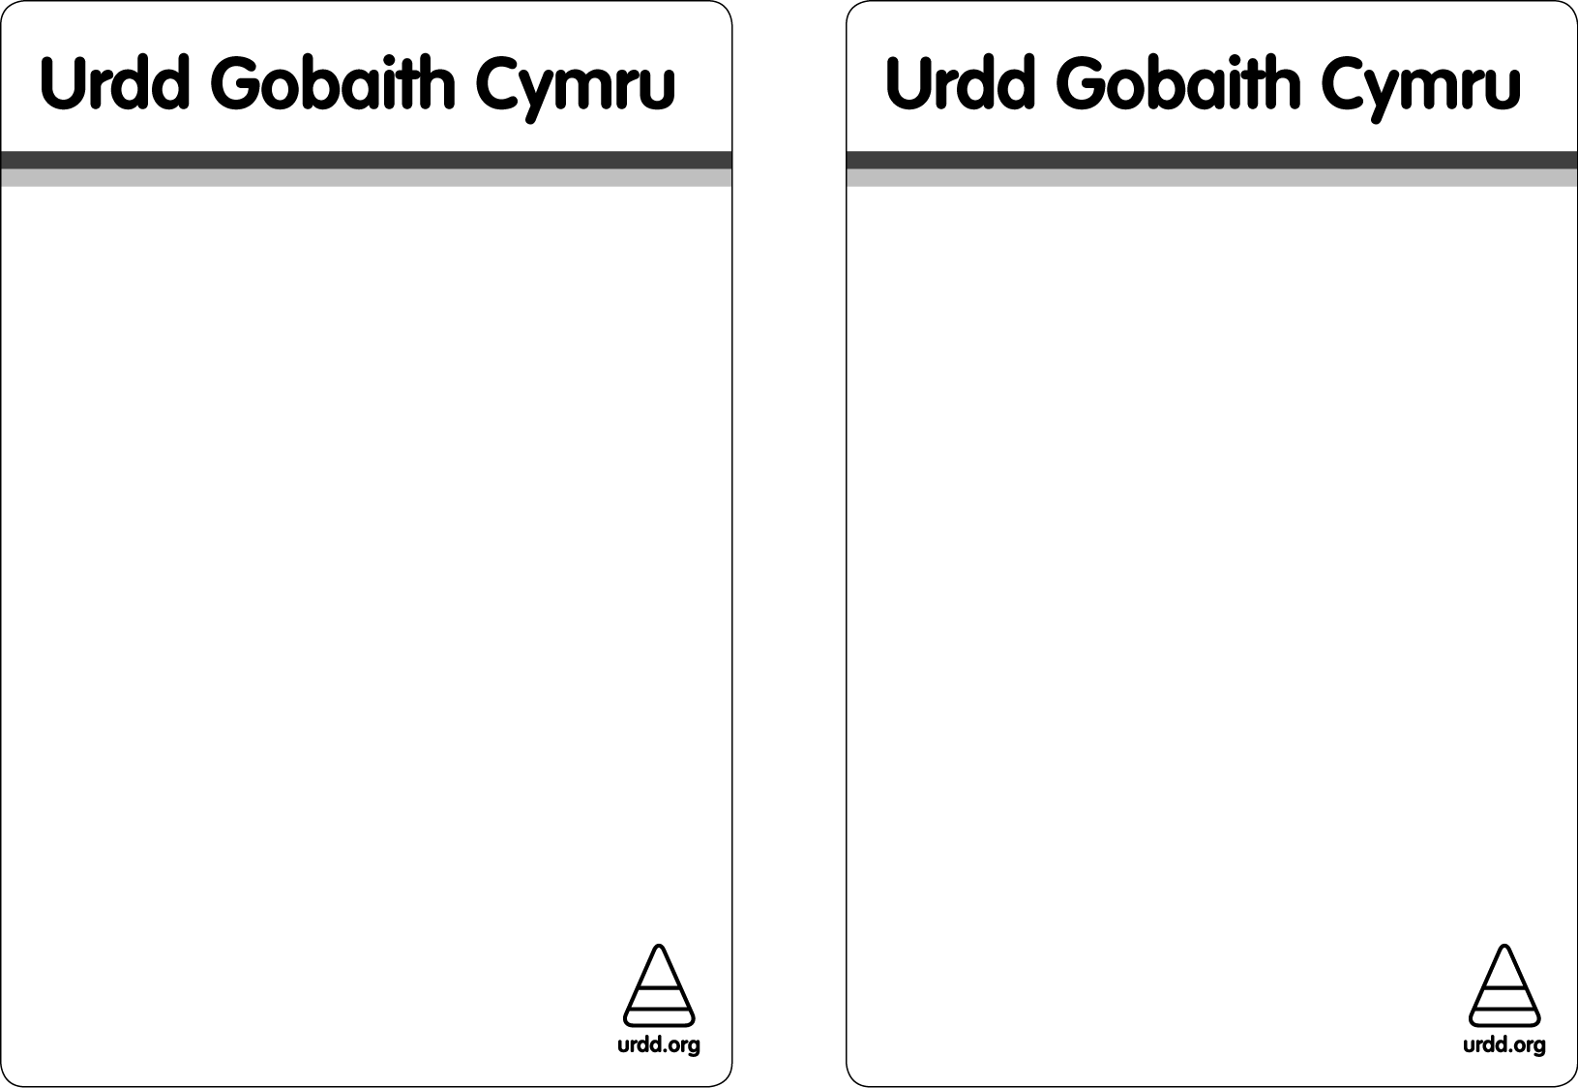

**ADRAN YR URDD PONTYPWL**

**URDD WELSH COMMUNITY CLUB**

**Canu a Drama**

***Singing and Drama***

**Adran cyntaf ar ol gwyliau’r Haf**

**Nos Lun 12 Medi 2016.**

**The First Adran after the summer will be on Monday 12 September2016**

**DEWCH YN LLU / EVERYONE WELCOME**

***Noson Ffilmiau***

***Film Night***

**Rhyngrwyd**

**WI**

**Gemau*Games*dd**

**Coginio**

**Cooking**

**ADRAN YR URDD PONTYPWL / URDD WELSH CLUB**

**Beth am annog eich plant i ymarfer siarad Cymraeg tu allan i oriau ysgol?**

*Are you looking for ways of encouraging your children to practise their Welsh outside school hours?*

***Ydych chi am i'ch plant gymdeithasu yn Gymraeg tu allan i oriau ysgol mewn awyrgylch diogel?***

*Would you like your children to socialise in a safe environment, and learn some more Welsh as well?*

***Mae Urdd Gobaith Cymru yn rhedeg Adran Gymunedol ar gyfer disgyblion ysgolion cynradd Cymraeg Torfaen***

*Urdd Gobaith Cymru runs an after school Welsh club for children who attend Welsh Medium Primary schools in Torfaen*

***Os oes diddordeb gyda chi dewch i NEUADD ISAF IAGO SANT, HEOL HANBURY, PONTYPWL AR NOS LUN RHWNG 4.30PM – 6PM. Byddai’n braf eich gweld yno.***

**CROESO I BAWB YM MLWYDDYN 3-6**

*If you are interested then please come along to* ***ST JAMES LOWER HALL, HANBURY ROAD PONTYPWL*** *on* ***MONDAY*** *between 4.30pm – 6pm. It would be good to see you.*

***ALL PUPILS IN YEAR 3-6 ARE WELCOME***

**Am fwy o fanylion / For more details please contact**

**Helen Greenwood, Swyddog Datblygu *Development Officer*. URDD GOBAITH CYMRU. (01495 350155)**

**Chwaraeon**

***Sports***

**Blwyddyn 3-6**

**Years 3-6**

**Mynd i’r Parc**

***Activities in the Park***

**Celf a Chrefft**

**Art and Craft**

