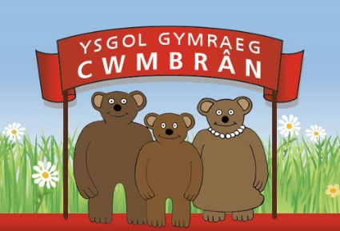
Polisi Gwisg Ysgol (Crynodeb)
Yn unol â dymuniad y rhieni a’r Bwrdd Llywodraethol, penderfynwyd cyflwyno polisi o wisg ysgol ar gyfer ein disgyblion. Deallwn nad oes gorfodaeth ar y disgyblion i wisgo gwisg ysgol ond credwn ei bod yn chwarae rhan allweddol wrth sicrhau disgyblaeth dda ac wrth sicrhau cysondeb a chydraddoldeb ar draws yr ysgol.

Nod ac amcanion:
Credwn bod y wisg ysgol yn:
- Creu’r ymdeimlad o falchder a pherthyn tuag at yr ysgol.
- Sicrhau bod cydraddoldeb yn yr ysgol o ran ymddangosiad.
- Smart ac yn gyffyrddus.
Rydym yn gwerthfawrogi bod prynu’r wisg ysgol yn ddrud ond ceisiwn ein gorau i gadw costau lawr i rieni / gwarchodwyr. Gofynnwn wrth bawb i drio’n galed i sicrhau bod pob disgybl yn gwisgo’r wisg gywir i’r ysgol bob dydd.

Y wisg ysgol:
Siwmper Coch (Gyda logo’r ysgol yn ddelfrydol.)
Cardigan Coch (Gyda logo’r ysgol yn ddelfrydol.)
Crys-T Gwyn neu coch (Gyda logo’r ysgol yn ddelfrydol.)
Trowsus Llwyd
Sgert Llwyd
Hosanau / Teits Du
Esgidiau Du (Nid yw trainers yn rhan o’r wisg ysgol.)
Ffrog Haf Coch a gwyn

School Uniform Policy (Summary)
In response to the parents’ and the Governing Body’s wishes, it was decided to present a school uniform policy for our pupils. We understand that it isn’t compulsory for the pupils to wear a school uniform but we think that the uniform plays a vital role when ensuring good discipline and consistency across the school.

Aims and objectives:
We feel that the school uniform does the following things:
- Creates the feeling of pride and belonging towards the school.
- Ensures equality in the school regarding appearance.
- Is smart and comfortable.
We appreciate that buying the school uniform can be expensive but we try our best to keep costs as low as possible for parents / guardians. We’re kindly asking everyone to try their best to ensure that the pupils wear the correct school uniform to school every day.

The school uniform:
Jumper Red (Ideally with the school logo.)
Cardigan Red (Ideally with the school logo.)
T-shirt White or red (Ideally with the school logo.)
Trousers Grey
Skirts Grey
Socks / Tights Black
Shoes Black (Trainers are NOT part of the school uniform.)
Summer dress Red and white

