Ysgol Gymraeg Cwmbrân

Ffordd Henllys,
Cwmbrân,
Torfaen
NP44 4HB
Ffôn: 01633 483383
Ffacs: 01633 485178
www.ysgolgymraegcwmbran.co.uk


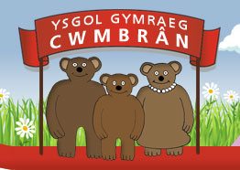
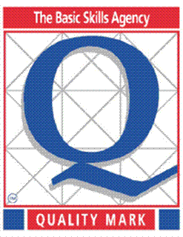

Gwisg Ysgol:

Annwyl Riant / Warchodwr,

Credwn bod y wisg ysgol yn chwarae rhan allweddol wrth sicrhau disgyblaeth dda ac wrth sicrhau cysondeb a chydraddoldeb ar draws yr ysgol. Gyda’r llythyr hwn, ceir crynodeb o’n polisi gwisg ysgol a gofynnwn i rieni a gwarchodwyr geisio sicrhau bod y disgyblion yn gwisgo’r wisg ysgol gywir i’r ysgol bob dydd.

Fel rydych chi’n gwybod, gallwch brynu ein gwisg ysgol o siop ‘Little Miss’ yng Nghwmbrân ond rydym hefyd wedi penderfynu treialu gwefan newydd sef gwefan uniformeasy. Trwy’r wefan hon, gellir prynu crys-T gyda bathodyn yr ysgol arno, siwmper neu gardigan gyda bathodyn yr ysgol arnynt a bag chwaraeon gyda’r bathodyn. (Ceir lluniau o rai o’r eitemau isod.)

Os ydych yn mynd ar y wefan, gallwch archebu unrhyw eitemau o wisg yr hoffech chi a bydd y dillad hyn yn cael eu harchebu gyda’i gilydd ac yn gael eu gollwng i’r ysgol pan mae’r archeb yn barod. www.uniformeasy.com/401450

Yn anffodus, nid ydym yn gallu newid maint y dillad neu eu newid am rai eraill felly gofynnwn yn garedig i chi sicrhau eich bod wedi archebu’r maint cywir cyn i chi dalu. Byddwn yn eich hysbysu chi pan mae’r eitemau yn barod i’w casglu o’r ysgol. Dylai’r archeb gymryd dim mwy na 21 diwrnod ar ôl y dyddiad isod.

** Rhaid i’r archebion fod mewn erbyn dydd Gwener, Mehefin 24ain ar gyfer sicrhau eu bod yma cyn diwedd y flwyddyn. Byddwn yn rhoi archeb arall ym mis Medi hefyd. Fydd unrhyw eitemau sy’n cael eu harchebu ar ôl y dyddiad hwn ddim yn cael eu harchebu tan fis Medi. **

Os oes unrhyw gwestiynau gyda chi neu os ydych chi eisiau unrhyw help gyda’ch archeb, cysylltwch gyda fi yn yr ysgol. Diolch, Miss Passmore

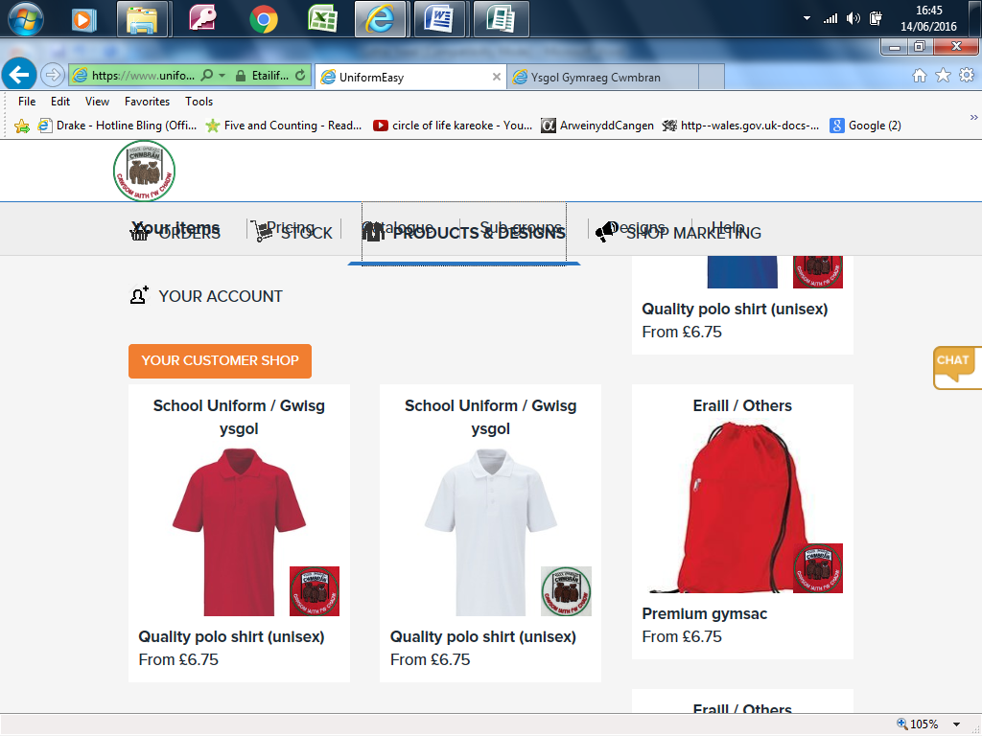
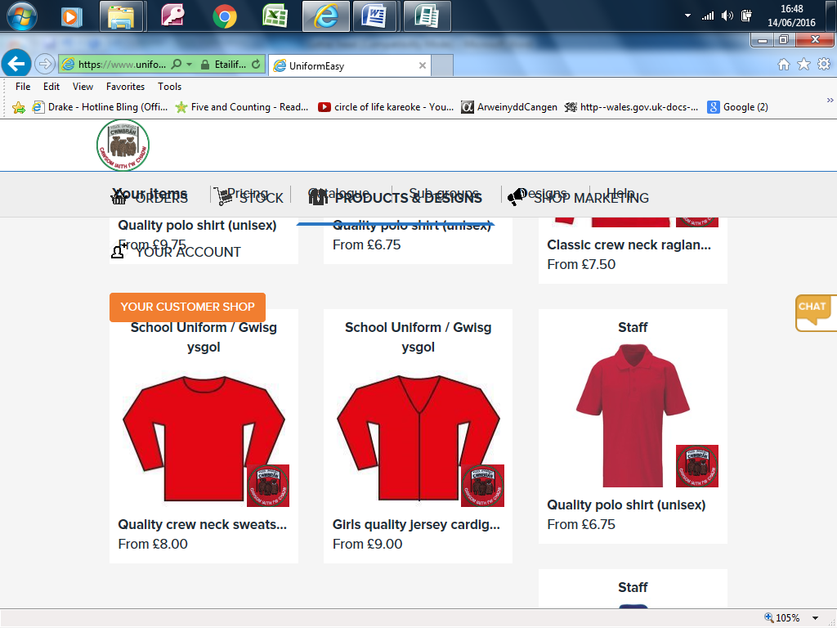

Ysgol Gymraeg Cwmbrân

Ffordd Henllys,
Cwmbrân,
Torfaen
NP44 4HB
Ffôn: 01633 483383
Ffacs: 01633 485178
www.ysgolgymraegcwmbran.co.uk

School Uniform:

Dear Parent / Guardian,

We feel that the school uniform plays a vital role when ensuring good discipline and consistency across the school. With this letter is a summary of our school uniform policy and we’re kindly asking parents and guardians to try to ensure that the pupils wear the correct school uniform to school every day.

As you are aware, you can buy our school uniform from ‘Little Miss’ in Cwmbrân but we have also decided to trial a new school uniform website called ‘uniformeasy’. Through this website, you can buy a T-shirt with the school logo, a jumper or cardigan with the school logo and a kit bag with the logo. (There are photos of some of the items below.)

If you go on the website, you can order any items you wish to buy and the order will then be delivered to the school free of charge. www.uniformeasy.com/401450

Unfortunately, once ordered, we are unable to change the size of the items so when placing your order, please check that the size is correct before paying. You will receive notification when your order is ready to collect from the school, which should be no more than 21 days.

** Any orders must be made by Friday, June 24th to ensure that we receive them back before the end of the year. We will be putting another order through in September. Any orders made after this date won’t be ordered until September. **

If you have any questions or if you would like any help with an order, please contact me at the school.

Thank you, Miss Passmore

