Ffordd Henllys,
Cwmbrân,
Torfaen
NP44 4HB
Ffôn: 01633 483383
Ffacs: 01633 485178
www.ysgolgymraegcwmbran.co.uk




Ysgol Gymraeg Cwmbrân

Pontypool Park Run:
Annwyl Riant / Warchodwr,
Ar ran staff Cyfnod Allweddol 2, hoffwn ddweud pa mor falch ydyn ni o ymdrech y disgyblion yn eu sesiynau ymarfer corff dyddiol. Mae’r disgyblion wedi bod yn gweithio’n galed iawn ers dechrau’r tymor ac mae eu ffitrwydd yn gwella o ganlyniad i’w hymroddiad a’u gwaith caled.
Gan fod y disgyblion wedi bod yn gwneud cystal, credwn y byddai’n syniad da i gefnogi y ‘Park Run’ lleol ym Mhontypwl ar ddydd Sul. Credwn y byddai hwn yn ffordd dda o weld sut mae eu lefel ffitrwydd wedi gwella ers dechrau’r flwyddyn a byddai hefyd yn cynnig ffordd o dracio eu lefel ffitrwydd yn y dyfodol.
Os ydy eich plentyn eisiau cymryd rhan dydd Sul, ewch i’r wefan isod. (Ceir linc i’r wefan ar wefan yr ysgol.) Does dim pwysau ar y disgyblion i gymryd rhan o gwbl, dim ond os ydyn nhw moyn dechrau tracio eu cyflymder rhedeg a dathlu’r ffaith bod eu ffitrwydd wedi gwella.
Mae’r ras yn dechrau ym Mharc Pontypwl am 09:00. (NP4 8AT) Os ydy eich plentyn yn dod i wneud y ras, gofynnwn yn garedig eich bod yn sicrhau bod oedolyn yn bresennol gyda nhw.

Dear Parent / Guardian,
On behalf of Key Stage 2 staff, I would like to say how proud we are of the pupils’ efforts with their daily fitness sessions; they have been working very hard since the beginning of the term and their fitness levels are improving as a result.
As the pupils have been doing so well, we thought it would be a lovely idea to support the local children's park run on Sunday in Pontypool Park. This would be a good way of seeing how the pupils’ fitness levels have improved since the start of the year and it will also offer them a way of tracking their running time in the future.
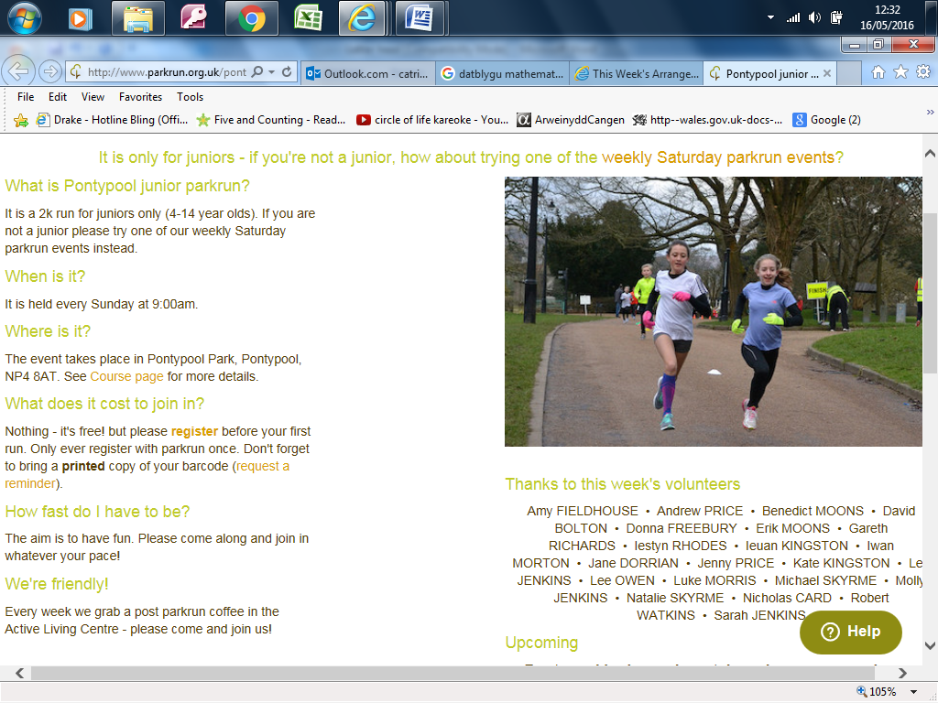
If your child would like to take part on Sunday, please see the link on the school website. http://www.parkrun.org.uk/pontypool-juniors/ The pupils don’t have to take part but it would be an ideal opportunity on Sunday to celebrate their improved fitness. If your child does want to take part, he/she will have to be accompanied by an adult.
(The adult does not have to take part in the run.)
The 1km run starts at Pontypool
Park at 09:00. (NP4 8AT)

Gobeithiwch eich gweld chi yno,
We hope to see you there,

Miss Passmore & KS2 staff.

