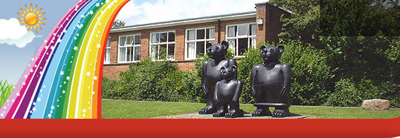
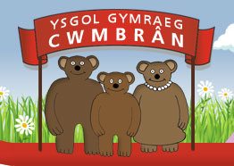
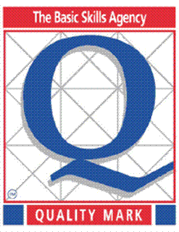
Ysgol Gymraeg Cwmbrân

Ffordd Henllys,
Cwmbrân,
Torfaen
NP44 4HB
Ffôn: 01633 483383
Ffacs: 01633 485178
www.ysgolgymraegcwmbran.co.uk

Annwyl Riant/Warchodwr
Dear Parent/Guardian

PWYSIG - Oes gennych chi hawl i brydau ysgol am ddim?
IMPORTANT - Are you entitled to free school meals?
Mae llawer yn ofni nad yw rhai teuluoeddd, plant a phobl ifanc yn dewis derbyn prydau ysgol am ddim oherwydd stigma. Gallai eich plentyn fod â hawl i brydau ysgol am ddim os ydych yn derbyn un o’r budd-daliadau/taliadau cymorth canlynol:
- Cymhorthdal Incwm
- Lwfans Ceiswyr Gwaith sy’n seiliedig ar incwm
- Cymorth o dan Ran VI o Ddeddf Lloches a Mewnfudo 1999
- Lwfans Cyflogaeth a Chymorth sy’n gysylltiedig ag incwm
- Credyd Treth Plant, cyn belled nad oes gennych hawl i Gredyd Treth Gwaith ac nad yw eich incwm blynyddol yn uwch nag £16,190
- Elfen warant o Gredyd Pensiwn y Wladwriaeth
- Credyd Treth Gwaith am gyfnod ychwanegol – y taliad y gallai rhywun ei dderbyn am bedair wythnos arall ar ôl iddynt fynd heibio trothwy’r Credyd Treth Gwaith
- Credyd Cynhwysol.

Mae ffurflenni cais ar gael o’r ysgol neu Free Meals Section, Croesyceiliog Community Education Centre, The Highway, Croesyceiliog. Rhif ffôn 01633 647715/19 neu fedrwch ddilyn y dolen cysllwt canlynol:
http://www.torfaen.gov.uk/en/EducationLearning/SchoolsColleges/FinancialSupport/Freeschoolmeals/Free-School-Meals.aspx
Am fwy o gyfarwyddyd, ewch i:
http://gov.wales/topics/educationandskills/schoolshome/foodanddrink/freeschoolmeals/?skip=1&lang=cy

BYDDWN YN DDIOLCHGAR PETAECH YN CYMRYD YR AMSER I WIRIO OS YDYCH YN GYMWYS.
………………………………………………………………………………………………………………………………………………………………………………………………………
There has been widespread concern that some families, children and young people might not be taking up their free school meals entitlement because of stigma. Your child may be eligible for free school meals if you are in receipt of any of the following benefits/support payments:
- Income Support
- Income Based Jobseekers Allowance
- Support under Part VI of the Immigration and Asylum Act 1999
- Income-related Employment and Support Allowance
- Child Tax Credit, provided they are not entitled to Working Tax Credit and their annual income does not exceed £16,190
- Guarantee element of State Pension Credit
- Working Tax Credit 'run-on' - the payment someone may receive for a further four weeks after they stop qualifying for Working Tax Credit
- Universal Credit.

Application forms for FSM are available from school or from the Free Meals Section, Croesyceiliog Community Education Centre, The Highway, Croesyceiliog. Tel: 01633 647715/19 or by following this link:
http://www.torfaen.gov.uk/en/EducationLearning/SchoolsColleges/FinancialSupport/Freeschoolmeals/Free-School-Meals.aspx

Please also read the guidance notes on: http://gov.wales/topics/educationandskills/schoolshome/foodanddrink/freeschoolmeals/?skip=1&lang=en
A hard copy of these guidance notes are available from the school office.

PLEASE TAKE THE TIME TO CHECK IF YOU ARE ELIGIBLE.

Yn gywir/Yours sincerely

C Evans

