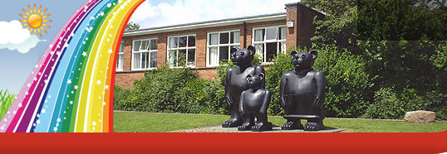
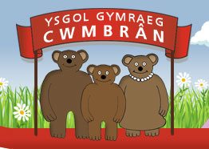
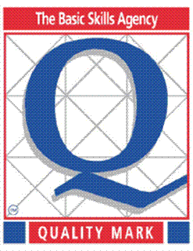
Ysgol Gymraeg Cwmbrân

Ffordd Henllys,
Cwmbrân,
Torfaen
NP44 4HB
Ffôn: 01633 483383
Ffacs: 01633 485178
www.ysgolgymraegcwmbran.co.uk

Adenydd i Hedfan (Blwyddyn 6):

Mae disgyblion blwyddyn 6 wedi cael eu gwahodd i Theatr y Congress, Cwmbrân ar fore dydd Iau, y 28ain o Ebrill ar gyfer gweld drama sydd wedi ei threfnu gan Heddlu Gwent. Bydd y disgyblion yn gwylio drama ar ddefnydd pobl ifanc o alcohol a chyffuriau a cheir moeswers ddefnyddiol yn y ddrama.

Mae bws wedi’i drefnu ar gyfer y daith a byddwn yn ôl cyn amser cinio.

Wings to Fly (Year 6):

Year 6 pupils have been invited to the Congress Theatre in Cwmbrân on the morning of Thursday, April 28th to see a play which has been arranged by Gwent Police. The play is based on young people’s use of alcohol and drugs. There is a very important message in the play for the pupils and they are taught about the dangers of peer pressure.

A bus has been arranged for this trip by Gwent Police and the pupils will be back before lunch.

Gofynnwn yn garedig i chi ddychwelyd y slip isod cyn i ni fynd.
Could you please return the slip below to the school as soon as possible?

Diolch / Thank you,
Miss Passmore.

Rhoddaf ganiatâd i fy mhlentyn / I give permission for my child

_________________________________________________

i deithio ar fws a gwylio’r ddrama ‘Wings to Fly’.

to travel on a bus and watch the play ‘Wings to Fly’.

Arwyddwyd / Signed: ________________________________

