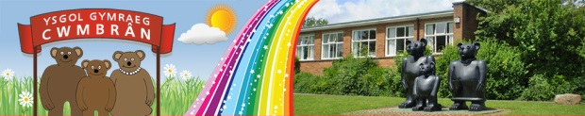
CALENDR/CALENDAR
Dyddiad/Date: | Digwyddiad / Event:
15/04/16 | Gweithdai hylendid bwyd yn ymweld â’r ysgol/Food hygiene roadshow visiting the school
16/04/16 | Arddangosfa Celf yr Urdd 10yb-2yp Canolfan y Methodistiaid Coeduon  Urdd Art Exhibition 10am – 2pm – Blackwood Methodist Centre
18/04/16 | Clwb Drama Blynyddoedd 3 a 4/Drama Club Years 3 and 4
19/04/16 | Côr pob nos Fawrth o 3:30yp i 4:30 yp/Choir every Tuesday 3:30 pm until 4:30pm
19/04/15 | Clwb Coginio i Flwyddyn 2 - Mrs Dalgleish – Llythyr i ddilyn - 3:30yp – 4:30yp  Cooking Club for Year 2 - Mrs Dalgleish – Letter to follow - 3:30pm – 4:30pm
20/04/16 | Urdd Club for Years 3 and 4/Clwb yr Urdd i Flynyddoedd 3 a 4
21/04/16 | Cwis Eco – Knauff Installation i rai o ddisgyblion Blwyddyn 5 a 6  Knauff Installation Eco Quiz for some Year 5 and 6 pupils
21/04/16 | Clwb ffitrwydd yn dechrau i Flynyddoedd 4, 5 a 6 – Amrywiaeth o chwaraeon gan gynnwys tennis, golff, athletau -3:30yp – 4:30yp  Fitness club starts for Years 4, 5 and 6 – Variety of activities including tennis, golf and athletics – 3:30pm – 4:30pm
25/04/16 | Clwb Drama Blynyddoedd 5 a 6/Drama Club Years 5 and 6
25/04/16 | Ffair Scholastic yn cychwyn am wythnos – cyfle i weld y llyfrau Dydd Llun a Dydd Mawrth ac i archebu Dydd Gwener  Scholastic Book Fayre – Children will have an opportunity to see the books on Monday and Tuesday and orders will be taken on the Friday
27/04/16 | Urdd Club for Years 5 and 6/Clwb yr Urdd i Flynyddoedd 5 a 6
28/04/16 | Blwyddyn 6 –Wings to Fly – Llythyr i ddilyn/Year 6 – Wings to Fly – 9:30am-11:30am – Letter to follow
29/04/16 | Diwrnod agored – cyfle i weld gwaith eich plentyn/Open day – an opportunity for you to see your child’s work
02/05/16 | Bank Holiday – No school/Gŵyl y Banc – Dim ysgol
03/05/16 – 10/05/16 | Profion statudol yn cychwyn i blant ym Mlynyddoedd 2 i 6/National tests for children in Years 2 to 6
04/05/16 | Urdd Club for Years 3 and 4/Clwb yr Urdd i Flynyddoedd 3 a 4
04/15/16 | P C Thomas yn ymweld â Blwyddyn 4 i drafod tobacco ac alcohol  P C Thomas visiting Year 4 to discuss tobacco and alcohol
09/05/16 | Clwb Drama Blynyddoedd 5 a 6/Drama Club Years 5 and 6
11/05/16 | Urdd Club for Years 5 and 6/Clwb yr Urdd i Flynyddoedd 5 a 6
11/05/16 | Blwyddyn 4 yn treulio’r noson yng ngwersyll yr Urdd yng Nghaerdydd – gadael am 9:30yb a dychwelyd y diwrnod canlynol am 4yp/  Year 4 pupils spending the night in the Urdd Centre in Cardiff – leaving at 9:30am and returning the following day at 4pm
16/05/16 | Clwb Drama Blynyddoedd 3 a 4/Drama Club Years 3 and 4
18/05/16 | Cŵn i’r deillion yn ymweld â Blwyddyn 1 a 2/Guide dogs for the blind visiting Years 1 and 2
18/05/16 | Twrnament Rygbi a phêl rwyd – Blaenafon – Llythyr i ddilyn  Rugby and Netball Tournament Blaenavon – Letter to follow
18/05/16 | Urdd Club for Years 3 and 4/Clwb yr Urdd i Flynyddoedd 3 a 4
22/05/16 | Disgyblion Cyfnod Allweddol 2 i wneud y Park Run yng Nghwmbrân – Llythyr i ddilyn  Key Stage 2 Pupils to take part in the Cwmbrân Park Run – Letter to follow
23/05/16 | Clwb Drama Blynyddoedd 5 a 6/Drama Club Years 5 and 6
23/05/16 | Wythnos Gwerthoedd – mwy o fanylion i ddilyn/Values Week – more details to follow
25/05/16 | Urdd Club for Years 5 and 6/Clwb yr Urdd i Flynyddoedd 5 a 6
27/05/16 | Diwedd Hanner Tymor/End of Half Term

06/06/16 | DIM YSGOL – HYFFORDDIANT I ATHRAWON/NO SCHOOL – TEACHER TRAINING DAY
07/06/16 | Plant yn dychwelyd i’r ysgol ar ôl y gwyliau/Children return to school following half term break.

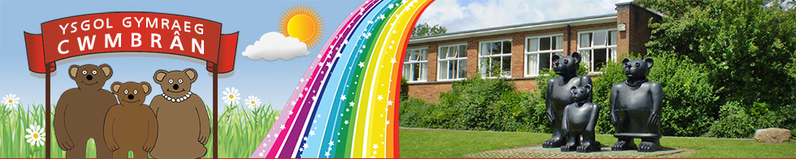

NEWYDDION/NEWS

Danfonwn longyfarchiadau mawr i Mrs Spanswick ar enedigaeth ei merch fach – Nel Glain.

Rydym yn hapus iawn gyda'r murluniau newydd sydd wedi cael eu paentio yn neuadd yr ysgol. Rydym hefyd wedi prynu sgrin ryngweithiol newydd ar gyfer y neuadd a fydd yn declyn defnyddiol iawn. Mae marciau iard ychwanegol wedi eu paentio ar iard Cyfnod Allweddol 2 sy’n golygu bod cae pêl-droed, cwrt rownderi a gemau targed parhaol gan y disgyblion. Maent hefyd yn hapus iawn gyda'u ffrâm ddringo newydd sydd wedi ei lleoli ar yr iard uchaf.

COFIWCH BOD PRIS PRYDAU YSGOL WEDI CYNYDDU - £2.10 i’r Cyfnod Sylfaen a £2.20 i Gyfnod Allweddol 2.

COFIWCH I LAWRLWYTHO’R APP SCHOOP ER MWYN DERBYN CYHOEDDIADAU PWYSIG – Cod yr ysgol yw 10319

We send our congratulations to Mrs Spanswick on the birth of her little girl – Nel Glain.

We are very pleased with the two new murals which have been painted in the school hall. We have also purchased a new interactive screen for the hall which will serve a multitude of purposes. Further yard markings have been painted on the Key Stage 2 yard. The pupils now have a permanent football pitch, rounders court and target games. The pupils are very pleased with their new climbing frame which is located on the top yard.

REMEMBER THAT THE PRICE OF SCHOOL MEALS HAS INCREASED - £2.10 for the Foundation Phase and £2.20 for Key Stage 2.

PLEASE DOWNLOAD THE SCHOOP APP ONTO YOUR PHONE TO RECEIVE IMPORTANT UPDATES FROM THE SCHOOL – Our School code is 10319

