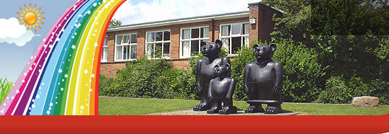
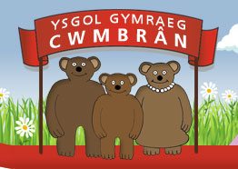
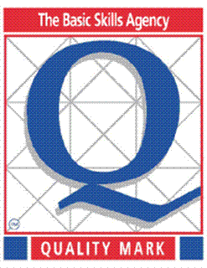
Ysgol Gymraeg Cwmbrân

Ffordd Henllys,
Cwmbrân,
Torfaen
NP44 4HB
Ffôn: 01633 483383
Ffacs: 01633 485178
www.ysgolgymraegcwmbran.co.uk

28/1/16

Rhowch eich hun yn esgidiau eich plentyn! Cyfle i chi ymgyfarwyddo â'r Profion Cenedlaethol

Fel y gwyddoch, mae'n statudol i ddisgyblion ym Mlynyddoedd 2-6 sefyll y profion cenedlaethol ym mis Mai. Teimlwn ei fod yn bwysig bod rhieni yn ymwybodol o'r hyn y mae’r profion yn cynnwys, eu fformat a rhai o'r heriau y gallai eich plentyn wynebu.

Yn ystod y Nosweithiau Rhieni sy’n cael eu cynnal ar y 9fed a 10fed o Chwefror, bydd Miss Evans a Miss Westphal wedi eu lleoli yn neuadd yr ysgol. Byddwch yn cael cyfle i weld enghreifftiau o'r math o gwestiynau a geir yn y papurau prawf, trafod strategaethau y gallwch ddefnyddio gartref i helpu'ch plentyn sydd yn debyg i’r dulliau rydym ym defnyddio yn yr ysgol.

Mae hwn yn gyfle ychwanegol i chi i gefnogi eich plentyn a helpu i ddatblygu eu sgiliau llythrennedd a rhifedd. Edrychwn ymlaen i’ch gweld.

Put yourself in your child’s shoes! Familiarise yourself with the National Tests

As you are aware, it is statutory for pupils in Years 2-6 to sit the national tests in May. We feel that it is important that parents are aware of what these tests entail, their format and some of the challenges that your child may face.

During the forthcoming Parents evenings which will be held on the 9th and 10th February, Miss Evans and Miss Westphal will be located in the school hall. You will have an opportunity to see some examples of the type of questions contained within the test papers and discuss strategies that you can employ at home to help your child which mirror those that we use in school.

You will have the opportunity to collect some guidance notes and age appropriate exemplar materials.

This is a further opportunity for you to support your child's learning and to help develop their literacy and numeracy skills. We look forward to seeing you.


