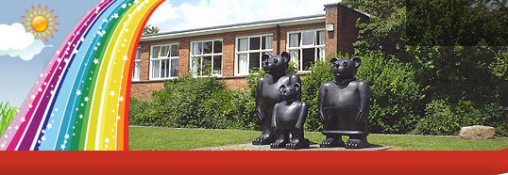
Ffôn:01633 483383
Ffacs: 01633 485178
www.ysgolgymraegcwmbran.co.uk

YsgolGymraegCwmbrân

FforddHenllys,
Cwmbrân,
Torfaen
NP44 4HB

Trip Cerddoriaeth i Neuadd Dewi Sant, Caerdydd i flwyddyn 5.
A music trip to St David’s Hall, Cardiff for year 5.
Annwyl Riant/Gwarchodwr,
Mae’r cynnig wedi dod i flwyddyn 5 i fynd i Neuadd Dewi Sant yng Nhaerdydd i weld cyngerdd ‘The Mozart Effect’ ar ddydd Mawrth, 23ain o Chwefror, 2016. Bydd y daith yn ystod oriau ysgol.
Pris tocyn gan gynnwys bws fydd £8. Os hoffech i’ch plentyn fynychu y daith, a wnewch chi lenwi’r slip isod a’i ddychwelyd i’r ysgol mor fuan a phosib?
Diolch,
Miss Griffiths

Dear Parent/Guardian,
Year 5 have an opportunity to attend a concert in St David’s Hall in Cardiff on Tuesday the 23rd of February to see ‘The Mozart Effect’. This will be during school hours.
The price for the ticket and bus will be £8. If you would like your child to attend the concert, please fill in the slip below and return it to your child’s teacher as soon as possible.
Thank you
Miss Griffiths
___________________________________________________________________

Enw plentyn/Child’s name ___________________________________
Hoffwn i fy mhlentyn fynd i weld ‘The Mozart Effect’ ar y 23ain o Chwefror.
I would like my child to attend ‘The Mozart Effect’ on the 23rd of February.

Please tick
Taliad o £8 Taliad i ddilyn
Payment of £8 Payment to follow
Arwyddwyd/Singnature ________________________________

