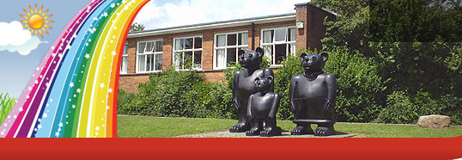
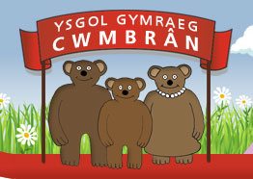

Ysgol Gymraeg Cwmbrân

Ffordd Henllys,
Cwmbrân,
Torfaen
NP44 4HB
Ffôn: 01633 483383
Ffacs: 01633 485178
www.ysgolgymraegcwmbran.co.uk

Nosweithiau Rhieni 2016:
Ar nos Fawrth, Chwefror 9fed a nos Fercher, Chwefror 10fed, byddwn yn cynnal nosweithiau agored yn yr ysgol. Bydd yn gyfle i chi gwrdd ag athrawon eich plentyn a thrafod ei gynnydd.

Trosodd, mae trefn y nosweithiau rhieni a cheir amser penodol i chi drafod gyda’r athro/athrawes. Er tegwch i bawb, gofynnwn yn garedig i chi gadw at yr amseroedd hyn.

Gofynnwn yn garedig i chi gwblhau’r rhwyglen isod a’i ddychwelyd i’r ysgol cyn gynted â phosibl.

Open Evenings 2016:
On Tuesday, February 9th and Wednesday, February 10th, we will be holding open evenings in the school. This will give you an opportunity to meet your child’s teacher and discuss your child’s progress.

Please refer to the timetable overleaf which has been arranged by your child’s teacher. We kindly ask that you adhere to your allocated time.

Should you wish to take advantage of this opportunity, please could you complete and return the slip below to your child’s teacher as soon as possible?

Byddaf / Ni fyddaf yn mynychu’r noson rhieni.

I shall / shall not be able to come to the school to discuss my child’s work.

Enw’r Plentyn / Name of Child: _______________________________

Arwyddwyd / Signed: _______________________________

