
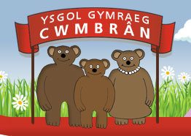
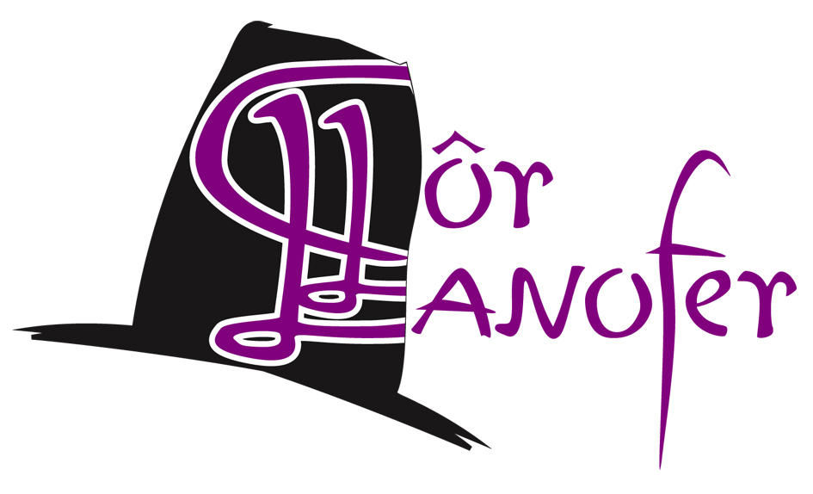

Ysgol Gymraeg Cwmbrân

Ffordd Henllys,
Cwmbrân,
Torfaen
NP44 4HB
Ffôn: 01633 483383
Ffacs: 01633 485178
www.ysgolgymraegcwmbran.co.uk

Gwent Music Concert, Christmas Extravagansa –13th of December
Cyngerdd Gwent Music, Christmas Extravagansa –13eg o Ragfyr.

Annwyl Riant / Warchodwr,

Dyma lythyr i’ch hatgoffa o drefniadau y gyngerdd dydd Sul:

Mae angen i chi ddod a’ch plentyn i brif fenedfa Canolfan Hamdden Casnewydd erbyn 10:00 bore Sul. Bydd angen casglu eich plentyn am 12:00 ac yna dod a fe/hi nôl erbyn 5:00 yn barod am y gyngerdd am 5:30.
Does dim ots beth fydd eich plentyn yn gwisgo i’r ymarfer ac nid oes rhaid iddynt fod mewn gwisg ysgol, ond ar gyfer y gyngerdd, mae angen iddynt wisgo crys gwyn, tei y côr, trwsus/sgert du, teits/sannau du ac hefyd esgidiau du. Mae croeso iddynt hefyd wisgo addurn bach Nadoligaidd yn eu gwallt.
Os nad ydych eisioes wedi gwneud, mae tocynnau ar gael ar y rhif yma: 01633 656 757. Os oes unrhyw gwestiwn gyda chi, cysylltwch gyda’r ysgol.

Diolch yn fawr, Miss Griffiths

Dear Parents / Guardians,

Here is a letter to remind you of the arrangements on Sunday:

Could you please ensure that your child is in the main reception of the Newport Leisure Center by 10:00am to meet me. Please collect your child at 12:00 from the main entrance and bring her/him back by 5:00pm ready for the concert at 5:30pm.

Your child doesn’t need to be in his/her school uniform in the morning as they can wear their own clothing but as for the concert, they will need to be in the choir uniform (white shirt, school tie, black trousers/skirt, black socks/tights and black shoes). They are welcome to have a small Christmas decoration in their hair, but no large head wear such as hats.

If you have not already purchased tickets, you can contact this number 01633656757
If you have any questions, please contact the school.

Thank you, Miss Griffiths

