Cymdeithas Rhieni ac Athrawon | 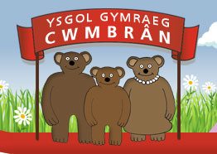 | Parent Teacher Association
Henllys Way, St Dials, Cwmbrân, NP44 4HB Email: ptaygc@hotmail.com
Cadeirydd/Chair: Vacant
Is-Gadeirydd/Vice-Chair: Laura Keenan 01633 674121
Trysorydd/Treasurer: Danielle Burchell 07926551211
Ysgrifenyddes/Secretary: Anna Charles
Dear Parent/Carer,
This term’s disco will be held at The White Hut (Coed Eva and Hollybush Community Hall, Penylan Roundabout, Hollybush way, NP44 7AG) on the first Sunday of half term, 3.30 – 5.30. There will be a raffle, tuck shop and children’s games. Come along in fancy dress – all welcome! The event remains unsupervised, so a parent/ carer to remain on site for the duration.
Tickets cost £2 per child. If you would like to purchase a ticket(s) please fill in the slip below and return to school with your payment as soon as possible. Due to hall capacity tickets will be limited.

Annwyl Riant / Warchodwr,
Bydd ein disgo y tymor hwn yn ‘The White Hut’ ar ddydd Sul cyntaf hanner tymor rhwng 3:30 a 5:30. Bydd raffl, siop a gemau. Mae tocynnau yn £2 ar gyfer bob plentyn a gallwch eu prynu cyn hanner tymor.

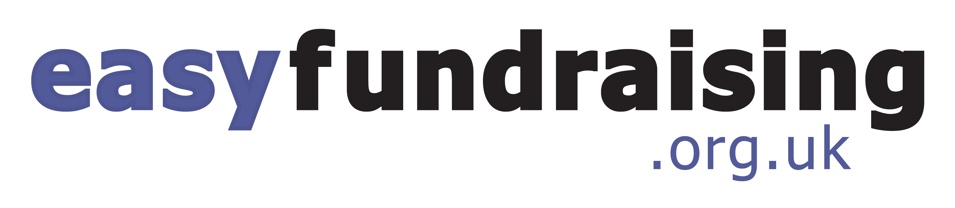
Do you shop online? If the answer is yes, you could be making money for the school at no extra cost to you. All you have to do is shop through the easyfundraising.org.uk website. Once you’ve signed up, you can shop at most stores and companies and a percentage of what you spend will go straight to the school, at no extra cost to you. You can shop on Ebay, Amazon, TESCO, Moonpig as well as paying for holidays, insurance, travel money etc.
All you need to do is go to easyfundraising.org.uk and choose Ysgol Gymraeg Cwmbran PTA. Please sign up and make some money for the school today. we’ve made £465.03 so far.
Ydych chi’n siopa ar lein? Os mai’r ateb yw ‘ydw’, gallech chi fod yn gwneud arian i’r ysgol, heb gostio unrhyw beth i chi. Yr unig beth sy’n rhaid i chi ei wneud yw siopa trwy wefan ‘easy fundraising’. Unwaith rydych chi wedi ymuno, gallwch chi siopa mewn nifer fawr o siopau a chwmnïoedd gwahanol a ni fydd hwn yn costio unrhyw arian ychwanegol i chi. Yr unig beth sy’n rhaid i chi ei wneud yw mynd i easyfundraising.org.uk a dewis Ysgol Gymraeg Cwmbran PTA. Gofynnwn yn garedig i chi ymuno gyda ni heddiw a dechrau gwneud arian i’r ysgol. Rydym wedi gwneud £465.03 hyd yn hyn.

Enw’r Plentyn / Child’s name _________________________
Dosbarth / Class _________________________
Nifer y tocynnau / Number of tickets required _________________________

