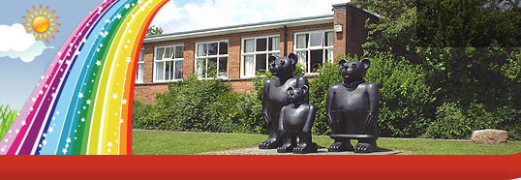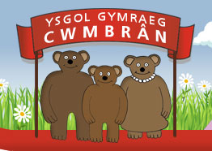

FforddHenllys,
Cwmbrân,
Torfaen
NP44 4HB
Ffôn: 01633 483383
Ffacs: 01633 485178
www.ysgolgymraegcwmbran.co.uk

Taith Llangrannog Blynyddoedd 5 a 6:

Annwyl Riant / Warchodwr,
Bob blwyddyn, mae disgyblion blynyddoedd 5 a 6 yn cael cyfle i fynd ar daith i Langrannog sef gwersyll yr Urdd yng Ngorllewin Cymru. Mae disgyblion blynyddoedd 5 a 6 o’r holl ysgolion Cymraeg sy’n bwydo Gwynllyw yn mynd ar y daith. Eleni, mae’r daith penwythnos i Langrannog rhwng yr 2 a’r 4ydd o Hydref. Cost y daith fydd £140 a bydd hwn hefyd yn cynnwys cost aelodaeth yr Urdd, sef £6.50, am y flwyddyn. Yn gynwysedig yn y pris hwn bydd holl fwyd y penwythnos, yswiriant, costau teithio, dros ddeg o weithgareddau a dwy noson yn y gwersyll.
Bydd y disgyblion yn gwneud amrywiaeth o weithgareddau dros y penwythnos megis sgïo, gwibgartio, nofio, merlota, saethyddiaeth ayyb. Gofynnwn yn garedig am y rhwyglen isod a blaendal o £30 cyn dydd Gwener, yr 11eg o Fedi.

Year 5 and 6 Llangrannog Trip:

Dear Parent / Guardian,
Each year, year 5 and 6 pupils are given the chance to visit the Urdd camp, Llangrannog with all the other schools that feed Ysgol Gyfun Gwynllyw. During the weekend, the pupils take part in a number of different activities including skiing, tobogganing, horse riding, swimming, archery etc. They will also get the chance to socialize in Welsh with pupils from six other Welsh medium schools.
This year, the weekend trip to Llangrannog for years 5 and 6 is between the 2nd and 4th of October.The cost of the trip is £140 which includes the annual £6.50 Urdd membership. Also included in the price is insurance, travel costs, food for the whole weekend, over ten activities and two nights in the camp.
We’re kindly asking for the slip below and a deposit of £30 before Friday, the 11thof September. Unfortunately, we will be unable to refund the deposit if your child is no longer able to attend.

If you have any questions about the trip to Llangrannog, please contact me.
Thank you, Miss Passmore.

Blaendal o £30 ar gyfer Llangrannog / £30 deposit for Llangrannog

Enw’r plentyn / Name of child: _____________________________

Arwyddwyd / Signed: _____________________________

