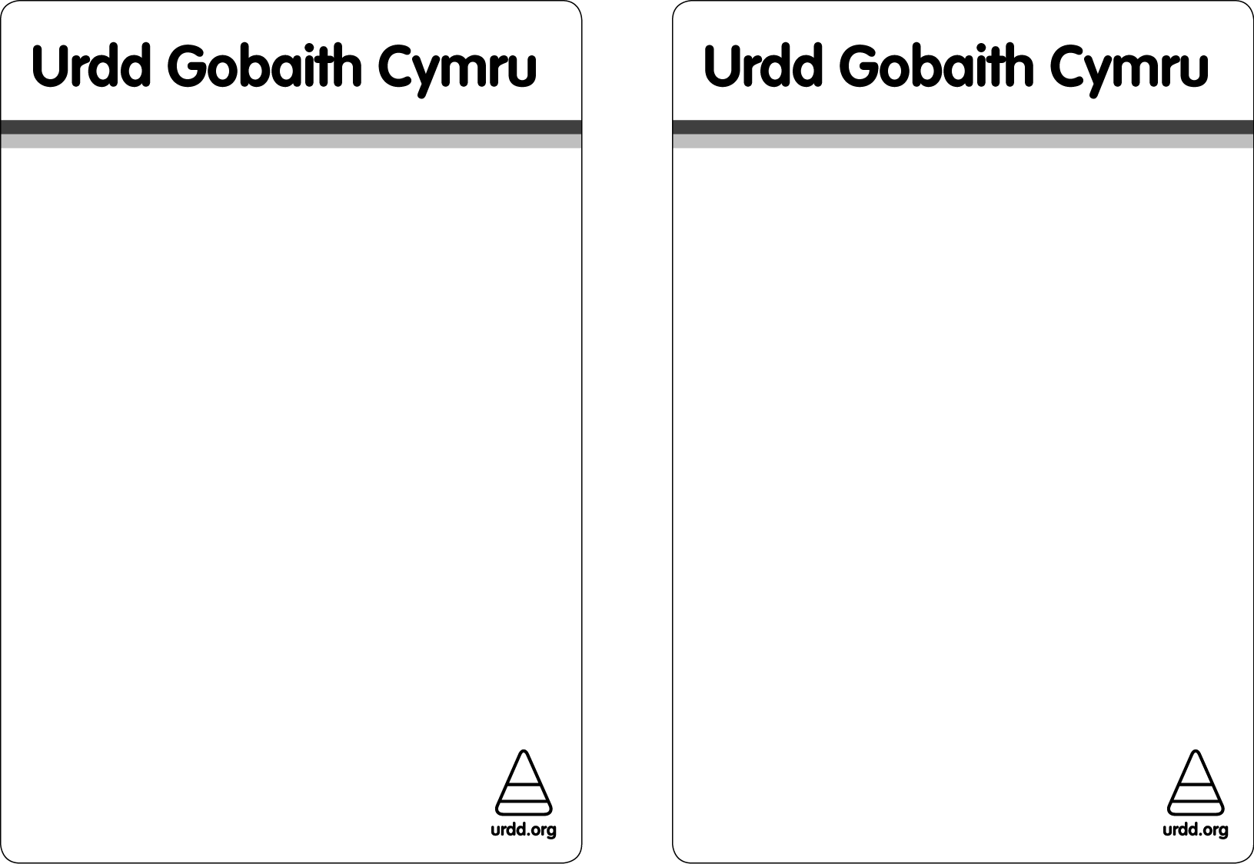
Noson Ffilmiau

Film Night
Blwyddyn 3-6
Years 3-6
GemauGamesdd
Rhyngrwyd
WI
Celf a Chrefft
Art and Craft
Canu a Drama
Singing and Drama
Coginio
Cooking
Mynd i’r Parc
Activities in the Park

Chwaraeon
Sports
Bydd yr Adran yn ail agor ar ol yr
haf ar Nos Lun 14 Medi 2015
The Adran will re open after the summer on Monday 14 Sept 2015
DEWCH YN LLU / EVERYONE WELCOME

ADRAN YR URDD PONTYPWL / URDD WELSH CLUB

Beth am annog eich plant i ymarfer siarad Cymraeg tu allan i oriau ysgol?
Are you looking for ways of encouraging your children to practise their Welsh outside school hours?

Ydych chi am i'ch plant gymdeithasu yn Gymraeg tu allan i oriau ysgol mewn awyrgylch diogel?
Would you like your children to socialise in a safe environment, and learn some more Welsh as well?

Mae Urdd Gobaith Cymru yn rhedeg Adran Gymunedol ar gyfer disgyblion ysgolion cynradd Cymraeg Torfaen

Urdd Gobaith Cymru runs an after school Welsh club for children who attend Welsh Medium Primary schools in Torfaen
Os oes diddordeb gyda chi dewch i NEUADD ISAF IAGO SANT, HEOL HANBURY, PONTYPWL AR NOS LUN RHWNG 4.30PM – 6PM. Byddai’n braf eich gweld yno.
CROESO I BAWB YM MLWYDDYN 3-6

If you are interested then please come along to ST JAMES LOWER HALL, HANBURY ROAD PONTYPWL on MONDAY between 4.30pm – 6pm. It would be good to see you.
ALL PUPILS IN YEAR 3-6 ARE WELCOME

Am fwy o fanylion / For more details please contact

Helen Greenwood, Swyddog Datblygu Development Officer. URDD GOBAITH CYMRU. (01495 350155)

ADRAN YR URDD PONTYPWL
URDD WELSH COMMUNITY CLUB

